ABSTRACT

ABSTRACT
MomentO is a smart and user-friendly event booking platform designed to simplify the process of planning and managing events such as weddings, birthdays, and corporate functions. In today’s fast-paced world, organizing events manually can be complex and time-consuming. MomentO provides a modern digital solution that allows users to explore events, customize services, and complete bookings easily.
The platform offers an interactive interface where users can select event types, choose services like decoration, catering, and photography, and view real-time cost calculations through an integrated budget calculator. Additionally, it includes an AI-powered chatbot to assist users by answering queries, suggesting services, and guiding them through the booking process.
To enhance user convenience, the system provides a WhatsApp chat integration, enabling users to directly communicate with event organizers for quick support and updates. The platform also introduces a flexible 3-month EMI (Equated Monthly Installment) option, allowing users to pay for their events in installments, making premium services more affordable.
The main objective of this project is to reduce manual effort, improve accessibility, and deliver a seamless booking experience. Future enhancements may include real payment gateway integration, user authentication, and admin dashboard features.
Overall, MomentO combines modern web technologies with smart features to provide an efficient, interactive, and customer-friendly event booking experience.

CONTENT

CHAPTER NO PAGE NO
Chapter1: INTRODUCTION

  - Brief Information about of the Project 01
  - Motivation and Contribution of Project 02
  - Objectives of the Project 03
  - Organization of Project 03
Chapter2: LITERATURE SURVEY 04
Chapter3: SYSTEM ANALYSIS
  - Existing system 06
  - Proposed System 06
  - Feasibility Study 07
  - Functional Requirements 08
  - Nonfunctional requirements 09
  - Requirement specifications 09
    - Minimum Software Requirements 09
    - Minimum Hardware Requirements 09
Chapter4: SYSTEM DESIGN
  - Introduction 10
  - System architecture 12
  - Modules description 13
  - UML Diagrams 14
    - Use case Diagram 15
    - Class Diagram 18
    - Sequence Diagram 20
    - Collaborative Diagram 23
    - Activity Diagram 24
Chapter5: TECHNOLOGY DESCRIPTION
  - Introduction 28
  - Introduction to HTML, CSS, and JavaScript 31
  - Introduction to Vue.js 34
  - Introduction to Node.js 37
  - Introduction to Email API (EmailJS) 39
  - Introduction to GitHub Actions 41
  - Introduction to Render 43
  - Introduction to Cloud Computing 46
  - Introduction to Tailwind 50
Chapter6: SAMPLE CODE 54
Chapter7: TESTING
  - Introduction 60
  - Sample test cases specifications 64
  - Test Case Screenshots 65
Chapter8: SCREENSHOTS 69
CONCLUSION 86
BIBLIOGRAPHY/REFERENCES 87

LIST OF TABLES

S.NO TABLE NO NAME OF THE TABLE PAGE NO

Use case template for acquiring customer
1 | 4.3.1.1
2 | 4.3.1.2
3 | 4.3.1.3
4 | 4.3.1.4
5 | 4.3.1.5
6 | 7.2

17
requirements
Use case template for exploring design

17
options
Use case template for cost estimation

18
process
Use case template for business owner data

18
updates
Use case template for CI/CD system interactions
18
Sample Test Case Specification 64

LIST OF FIGURES

S.NO | FIGURENO | NAMEOFTHE FIGURE PAGENO
01 | 4.2.1 | System Architecture 14
02 | 4.4.1 | Use case diagram for system 18
03 | 4.4.2 | Class diagram for system 23
04 | 4.4.3 | Sequence diagram for system 24
05 | 4.4.4 | Collaboration diagram for system 26
06 | 4.4.5 | Activity diagram for system 28

LIST OF SCREENS

S.NO | SCREENNO | NAMEOFTHE SCREEN PAGENO
01 | 8.1 | Screen shot for Welcome Animation 78
02 | 8.2 | Screen shot for Register 79
03 | 8.3 | Screen shot for Successful Login 80
04 | 8.4 | Screen shot for Home Page 81
05 | 8.5 | Screen shot for About Section 82
06 | 8.6 | Screen shot for Events Section 82
07 | 8.7 | Screen shot for Calender 83
08 | 8.8 | Screen shot for Gallery 83
09 | 8.9 | Screen shot for Pricing Packages 84
10 | 8.10 | Screen shot for Investment Calculator 84
11 | 8.11 | Screen shot for Admin Login 85
12 | 8.12 | Screen shot for After Successful Admin  Login 86
13 | 8.13 | Screen shot for Reviews 86
14 | 8.14 | Screen shot for Booking Panel 87
15 | 8.15 | Screen shot for Meet Our Team 87
16 | 8.16 | Screen shot for Contact 88
17 | 8.17 | Screen shot for Payment Gateway 89
18 | 8.18 | Screen shot for AWS Dashboard 90
19 | 8.19 | Screen shot for AWS Instances 91

LIST OF ABBREVIATIONS

S. No Abbreviatios Stands For

1 | UI | User Interface
2 | UX | User Experience
Continuous Integration / Continuous
3 CI/CD
 |  | Deployment
4 | API | Application Programming Interface
5 | CRM | Customer Relationship Management
6 | HTML | HyperText Markup Language
7 | CSS | Cascading Style Sheets
8 | JS | JavaScript
9 | SQL | Structured Query Language
10 | AWS | Amazon Web Services
11 | CDN | Content Delivery Network
12 | SEO | Search Engine Optimization
13 | HTTP | HyperText Transfer Protocol
14 | HTTPS | HyperText Transfer Protocol Secure
15 | DBMS | Database Management System

CHAPTER 1 INTRODUCTION

Momento-Event Booking platform

INTRODUCTION

1.1 Brief Information about the Project
MomentO is a web-based event booking platform developed using React.js to provide a modern, fast, and interactive user experience for planning and managing events. The project is designed to simplify the process of booking events such as weddings, birthdays, and corporate functions through a dynamic and responsive interface.

The application allows users to explore different event categories, select required services like decoration, catering, and photography, and view the total cost instantly using a real-time budget calculator. The use of React components ensures smooth navigation and efficient rendering of data without reloading the page.

To improve user interaction, the platform includes an AI-powered chatbot that helps users with queries, provides suggestions, and guides them throughout the booking process. Additionally, the system offers WhatsApp chat integration for direct communication with event organizers, making support quick and convenient.

The platform also introduces a flexible 3-month EMI (Equated Monthly Installment) option, allowing users to pay for their bookings in installments, which makes premium services more affordable.

The project is built using React.js for the frontend and can be integrated with backend technologies like Node.js and MongoDB for data management and storage. The main objective of MomentO is to reduce manual effort, enhance user experience, and provide a seamless and efficient event booking system.

1

1.2 Motivation and Contribution of Project

Motivation:
The motivation behind developing the MomentO project is to address the challenges faced in traditional event planning, which often involves time-consuming manual work, difficulty in managing budgets, and lack of proper communication with service providers. Many existing systems do not offer a simple and interactive way for users to plan events efficiently. Therefore, this project aims to create a modern and user-friendly platform using React that simplifies the entire event booking process. By integrating advanced features such as a real-time budget calculator, AI-powered chatbot, WhatsApp support, and EMI payment options, MomentO is designed to enhance convenience, improve user experience, and make event planning more accessible, efficient, and affordable for everyone.

Contribution:
The MomentO project contributes to the event management domain by providing a modern, efficient, and user-friendly event booking platform developed using React. It simplifies the overall process of event planning by allowing users to easily explore events, customize services, and book them through a dynamic interface. The integration of a real-time budget calculator helps users make informed decisions by instantly estimating costs. Additionally, the inclusion of an AI-powered chatbot enhances user support by guiding users and answering their queries effectively. Features like WhatsApp chat integration improve communication between users and service providers, while the 3-month EMI payment option makes event booking more affordable and accessible. Overall, the project reduces manual effort, saves time, and improves the efficiency and user experience of event management systems.

1.3 Objectivesof the Project

The main objective of the MomentO project is to develop a modern and user-friendly event booking platform that simplifies the process of planning and managing events. The system aims to provide an interactive interface where users can easily explore different event types, customize services, and complete bookings efficiently. Another objective is to implement a real-time budget calculator that helps users estimate costs instantly and make better decisions.
The project also focuses on enhancing user support by integrating an AI-powered chatbot to assist users and resolve their queries. Providing WhatsApp chat integration is another key objective, enabling direct and quick communication with service providers. Additionally, the platform aims to introduce a flexible 3-month EMI payment option to make event booking more affordable.
Overall, The objective is to reduce manual effort, save time, improve accessibility, and deliver a seamless and efficient event booking experience using modern technologies like React.

1.4 Organization of the Project

• The Literature Survey contains the background of the MomentO Event Booking Platform,
existing event management systems, possible approaches, and comparison of technologies
used in MERN stack (MongoDB, Express.js, React.js, Node.js).

• The System Analysis describes the current manual event booking system and its limitations, along with the proposed MomentO system. It also includes system requirements such as functional and non-functional requirements and the overall working of the platform.

• The System Design consists of module descriptions of the MomentO platform such as user module, event booking module, admin module, and payment module. It also includes UML diagrams like use case diagram, class diagram, sequence diagram, and activity diagram.

• The Technology Description explains the technologies used in this project, including MongoDB for database, Express.js and Node.js for backend development, and React.js for frontend development.

• The Sample Code section provides code snippets of important modules such as booking system, budget calculator, chatbot integration, and API handling.

• The Testing section includes testing methods and test cases applied to ensure the proper functioning of modules like booking, login, and payment features.

CHAPTER 2 LITERATURE SURVEY

Momento-Event Booking Platform

LITERATURE SURVEY

1. Momento-Event Booking Platform: Principles and Practices
Author: Julia Rutherford Silvers
Abstract:
This book provides a comprehensive understanding of event management concepts, including planning, organizing, and executing various types of events such as weddings, corporate functions, and social gatherings. It highlights important aspects like budgeting, vendor coordination, scheduling, and client communication. The book also discusses challenges faced in traditional event planning, such as time management, resource allocation, and maintaining quality services. Additionally, it emphasizes the use of digital tools and modern technologies to improve efficiency and user experience. These insights are useful for developing platforms like MomentO, which aim to simplify and automate the event booking process.

2. A Study on Online Event Booking Systems and User Experience
Authors: Various Researchers
Abstract:
This research focuses on analyzing existing online event booking systems and evaluating their effectiveness in terms of usability, performance, and customer satisfaction. The study identifies common limitations such as lack of real-time cost estimation, poor user interface design, and limited communication between users and service providers. It highlights the importance of interactive features, responsive design, and seamless navigation in improving user experience. The research also emphasizes the role of modern web technologies like the MERN stack (MongoDB, Express.js, React.js, Node.js) in building scalable and efficient web applications. The findings support the development of the MomentO platform, which integrates features like budget calculation, chatbot assistance, and real-time booking to enhance usability and performance.

3. Event Booking System Management Processes: An Exploratory Study
Authors: Hafez Salleh, Nurul Aini Abdul Samad, and Nurul Syala Abdul Latif
Abstract:
This study explores the key processes involved in managing online event booking systems and identifies multiple factors that contribute to the successful execution of event planning platforms. Through case studies and system analysis, the research examines how different management approaches impact the efficiency and effectiveness of event booking systems. It focuses on important aspects such as user management, booking process handling, budget control, service selection, and communication between users and service providers.
The study also highlights the importance of integrating modern web technologies like the MERN stack (MongoDB, Express.js, React.js, Node.js) to improve system performance, scalability, and data management. Additionally, it emphasizes the role of digital tools such as real-time cost calculation, chatbot assistance, and online communication features in enhancing user experience.
The findings provide a structured approach for developing efficient event booking platforms like MomentO, helping improve workflow, reduce manual effort, and increase user satisfaction through better system design and technology integration.

CHAPTER 3 SYSTEM ANALYSIS

SYSTEM ANALYSIS

Existing System

In the existing system, event planning and booking are mostly handled manually or through basic online platforms with limited features. Users often need to contact multiple vendors separately for services like decoration, catering, and photography. There is no centralized system to manage bookings, track budgets, or customize services efficiently. Communication between users and service providers is also not streamlined, leading to confusion and delays.

Additionally, many existing platforms lack advanced features such as real-time cost calculation, chatbot assistance, and flexible payment options. This makes the overall process time-consuming, less interactive, and inefficient for users.

Disadvantages

• Lack of centralized event booking system
• Time-consuming manual process
• No real-time budget calculation
• Limited communication between users and vendors
• Lack of customization in service selection
• No smart assistance (chatbot support)
• No flexible payment options like EMI

3.2 Proposed System

The proposed system, MomentO, is a modern event booking platform developed using the MERN stack (MongoDB, Express.js, React.js, Node.js). It provides a centralized and user-friendly interface where users can explore events, customize services, and complete bookings

The system includes advanced features such as a real-time budget calculator, an AI-powered chatbot for user assistance, and WhatsApp chat integration for direct communication with service providers. It also introduces a 3-month EMI payment option, making event booking more affordable.

The platform ensures smooth performance, scalability, and efficient data management through the MERN stack. It significantly reduces manual effort and improves the overall user experience by automating the event booking process.

Advantages

• Centralized event booking system
• Easy and fast booking process
• Real-time budget calculation
• AI chatbot support for user guidance
• WhatsApp integration for communication
• Flexible payment options (EMI)
• Improved user experience with React
• Scalable and efficient system using MERN stack

Implementation Steps
- Application Development:
Develop the frontend using React.js for building a dynamic and responsive user interface. Use Node.js and Express.js for backend development and MongoDB for database management. Implement features like event booking, service selection, budget calculator, AI chatbot, and EMI options.
- Version Control & CI/CD:
Host the project code on GitHub and use GitHub Actions to enable Continuous Integration and Continuous Deployment (CI/CD) for automatic building and updating of the application.
- Deployment:
Deploy the MERN stack application using platforms like Render or other cloud services, ensuring smooth hosting, scalability, and performance.
- Security & Access Management:
Use environment variables to securely store sensitive data such as database connection strings, API keys, and authentication details.
- Communication Integration:
Implement features like WhatsApp chat integration and optional email notifications for booking confirmations and user updates.
- Testing & Monitoring:
Perform testing on all modules such as booking, login, and payment features. Monitor application performance using built-in tools provided by the hosting platform.
3.2 Feasibility Study
A feasibility study evaluates the practicality and effectiveness of developing the MomentO Event Booking Platform using the MERN stack. It analyzes the system based on Operational, Technical, and Economic feasibility.
Operational Feasibility
The MomentO system is designed to improve the efficiency of event booking by providing a user-friendly and interactive platform. It reduces manual effort by automating the booking process and offers features like real-time budget calculation, AI chatbot assistance, and direct communication through WhatsApp. The system ensures smooth operation and better user experience, making it highly feasible for real-world usage.

Technical Feasibility

The MomentO system is developed using the MERN stack, which includes MongoDB, Express.js, React.js, and Node.js, ensuring high performance, scalability, and flexibility. React.js is used to build a dynamic and responsive user interface, while Node.js and Express.js handle backend operations efficiently. MongoDB provides a scalable and flexible database for storing user and booking data.
This technology stack is widely supported across different platforms, making deployment smooth and reliable. The system can be integrated with modern tools like GitHub for version control and CI/CD pipelines to automate the development and deployment process. Additionally, features such as AI chatbot integration, WhatsApp communication, and real-time budget calculation enhance system functionality and user experience. Overall, the chosen technologies make the system technically feasible, efficient, and easy to maintain.

Economic Feasibility

The MomentO platform is economically feasible as it is developed using open-source technologies like React.js, Node.js, and MongoDB, which do not require licensing costs. Deployment can be done using cost-effective cloud platforms that offer free and affordable plans.
The system is designed to optimize resource usage by efficiently handling user requests and scaling when required. This reduces operational costs while maintaining good performance. Additionally, features like EMI payment options make the platform more attractive to users, indirectly supporting business growth and revenue generation. Hence, the project maintains a balance between cost and performance.

Functional Requirements

• The system should allow users to register and log in securely
• Users should be able to browse and select different types of events (wedding, birthday, corporate, etc.)
• The system should allow users to customize services such as decoration, catering, and photography
• The platform should provide a real-time budget calculator to estimate total cost
• The system should support event booking and confirmation
• The platform should include an AI chatbot to assist users and answer queries
• The system should provide WhatsApp chat integration for direct communication
• The system should support EMI payment option (3 months) for flexible payments
• Admin should be able to manage bookings, users, and services
• The system should securely store user data using MongoDB
• The application should provide authentication and authorization for user security
• The system should handle multiple users efficiently with good performance

Non-Functional Requirements

• The system should ensure low latency and fast response time for smooth user interaction
• The application should be scalable to handle increasing number of users efficiently
• The system should ensure high availability and reliability with minimal downtime
• The platform should implement secure authentication and authorization to protect user data
• The system should ensure secure API communication between frontend and backend
• The application should provide a responsive and user-friendly interface using React
• The system should optimize performance and resource utilization
• The platform should support real-time updates and monitoring for better performance tracking
• The system should maintain data consistency and integrity in MongoDB

Requirements Specifications

Software Requirements
• Operating System: Ubuntu / Windows
• Technologies: MongoDB, Express.js, React.js, Node.js (MERN Stack)
• Frontend: React.js
• Backend: Node.js with Express.js
• Database: MongoDB
• Tools: Visual Studio Code, GitHub, Postman

Hardware Requirements

• Processor: 12th Gen Intel Core i5-12450H
• Speed: 2.00 GHz
• RAM: 12 GB
• Hard Disk: 477 GB (SSD)
• Graphics: Intel UHD Graphics
• System Type: 64-bit Operating System, x64-based processor

CHAPTER 4 SYSTEM DESIGN

SYSTEM DESIGN

Introduction

The system design phase of the MomentO Event Booking Platform focuses on transforming the user requirements into a well-structured solution. It acts as a bridge between the problem and the implementation by defining the overall architecture and system components. The platform is designed using the MERN stack (MongoDB, Express.js, React.js, Node.js) to ensure scalability and performance. This phase identifies major modules such as user management, event booking, and payment handling, and explains how these components interact with each other. It also ensures that the system is efficient, user-friendly, and easy to maintain. Overall, the design phase provides a clear blueprint for the development, testing, and maintenance of the application.

System Design

The System Design of the MomentO Event Booking Platform defines the overall structure of the application using the MERN stack. It identifies key modules such as user management, event booking, service customization, and payment handling. Each module is designed to perform specific functions and interact with others through APIs. The React frontend and Node.js backend ensure smooth and dynamic performance.
The system uses MongoDB to store user, event, and booking data efficiently. It ensures proper communication between frontend and backend for real-time updates. Overall, the design supports scalability, performance, and easy maintenance.

Key Aspects of System Design:

• Identification of Modules: Defining major modules such as User Module, Event Module, Booking Module, Payment Module, and Admin Module
• Specification of Modules: Describing the functionality of each module and how they interact through APIs
• Data Structures & Database Design: Designing MongoDB schemas for users, bookings, events, and services
• Output Formats: Defining how information like booking details, total cost, and confirmations are displayed in the React UI
• Software Component Relationships: Ensuring smooth communication between frontend (React) and backend (Node.js, Express.js)
• Blueprint for Implementation: Providing a clear structure for developing, testing, and maintaining the MomentO application

System Architecture

The system architecture of the MomentO Event Booking Platform is designed using the MERN stack, which ensures a scalable and efficient application structure:

- Frontend: Developed using React.js to provide a dynamic and responsive user interface
- Backend: Implemented using Node.js and Express.js to handle API requests and business logic
- Database: Managed using MongoDB for storing user data, event details, and bookings
- Hosting & Deployment: The application can be deployed on cloud platforms like Render for reliable performance
- API Communication: RESTful APIs are used to connect frontend and backend
- Integration Features: Includes AI chatbot, WhatsApp communication, and budget calculator

Modularity

Modularity is an important property of the MomentO system, where the application is divided into multiple independent modules such as user module, event module, booking module, and admin module. This separation reduces dependency between components and improves system organization:

- Simplifies debugging and maintenance
- Enhances code reusability
- Improves scalability
- Supports parallel development by multiple developers

System Architecture:

Fig4.2.1 System Architecture
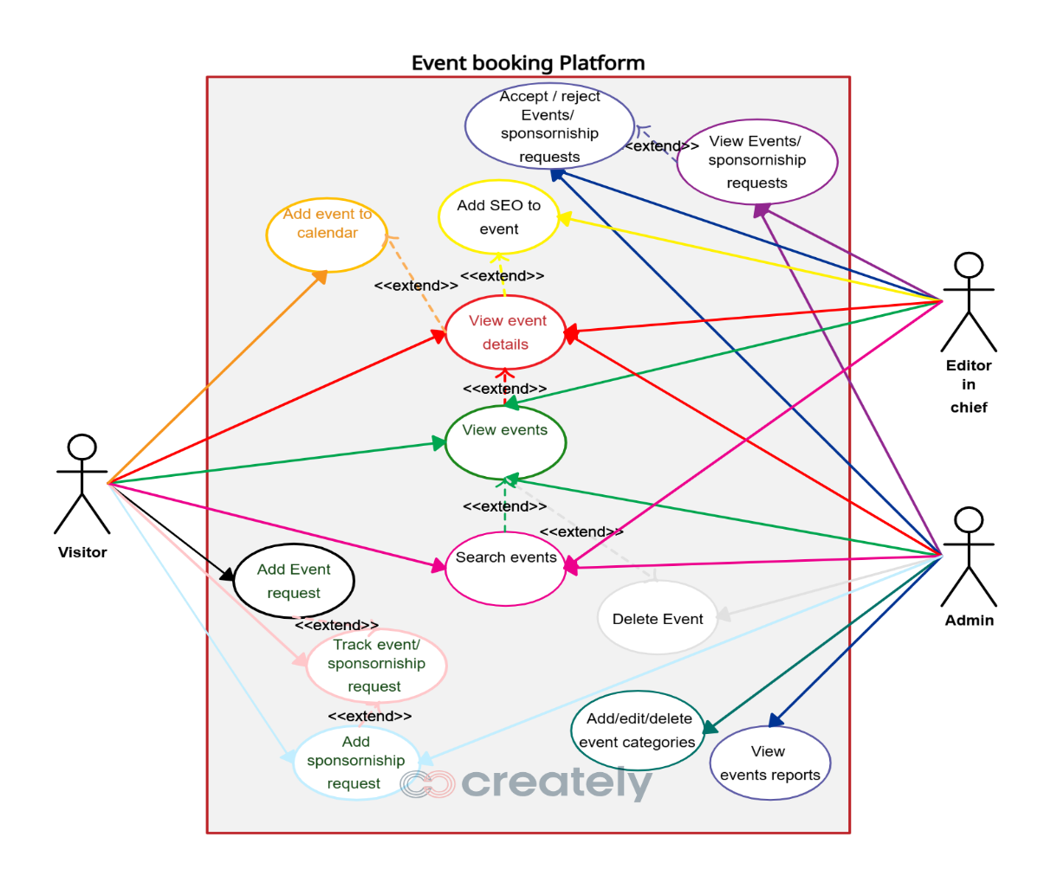

Architecture Description:

The MomentO Event Booking Platform enables users to explore events, view packages, and submit booking requirements in a simple and efficient way. It includes advanced features such as an AI chatbot, WhatsApp chat support, and a budget calculator with EMI options to enhance user experience. The platform is built using the MERN stack (MongoDB, Express.js, React.js, Node.js), where React.js provides a dynamic user interface, Node.js and Express.js handle backend logic, and MongoDB stores user, event, and booking data. This architecture ensures smooth communication between components, scalability, and efficient system performance while allowing easy management and updates.

Module Descriptions

- User Access & Authentication
  - Provides secure login and registration for users
  - Supports roles such as customers and admin
  - Ensures authentication and authorization using JWT

Explore Events
  - Allows users to browse different event categories (weddings, parties, corporate events)
  - Displays event packages, images, and details.
  - Provides filtering and search options for better user experience

Event Inspiration & Gallery
  - Users can view and save event ideas and themes
  - Helps users choose designs, decorations, and arrangements
  - Provides visual inspiration for event planning

Event Requirement Submission
  - Allows users to enter event details like date, location, guests, and preferences
  - Provides an easy-to-use form interface

Automated Responses & Notifications
  - Sends instant booking confirmations via email or WhatsApp
  - Provides automated responses using chatbot integration
  - Keeps users updated with booking status

Customer & Booking Management
  - Stores user and booking details in database
  - Allows admin to view, update, and manage booking
  - Helps in tracking user activity and history

Budget Calculator & Payment Options
  - Estimates event cost based on user inputs
  - Provides budget planning features
  - Includes 3-month EMI option for flexible payments

Follow-Up & Customer Engagement
  - Enables timely follow-ups through automated notifications and reminders
  - Integrates chatbot and WhatsApp support for better user interaction
  - Improves customer engagement and satisfaction

CI/CD Integration
  - Supports automated deployment using tools like GitHub Actions
  - Ensures quick updates and feature releases without downtime
  - Reduces manual work and improves development efficiency

Admin Dashboard
  - Provides a dashboard for admin to manage users, events, and bookings
  - Displays insights such as total bookings, revenue, and user activity
  - Allows easy control and monitoring of the platform

Scalability & Cloud Deployment
  - Deployed on cloud platforms for high availability
  - Supports scaling to handle multiple users efficiently
  - Ensures reliable performance during high traffic

Monitoring & Logging
  - Tracks system performance and user activity
  - Helps in debugging and improving system efficiency
  - Maintains logs for security and analysis

UML Diagrams
The Unified Modeling Language (UML) is used in the MomentO Event Booking Platform to visually represent the system design and structure. It helps in understanding how different components of the MERN stack application interact with each other. UML provides a clear representation of both the functional and structural aspects of the system.

In this project, UML is divided into analysis modeling and design modeling. Analysis modeling focuses on user interactions and system structure, while design modeling focuses on behavior, implementation, and environment. The main UML diagrams used include Use Case Diagram, Class Diagram, Sequence Diagram, Activity Diagram, and Collaboration Diagram, which together provide a complete view of the system. These are divided into the following types:-
- Use case diagram

- Class diagram
- Sequence diagram
- Collaboration diagram
- Activity diagram

Use Case diagram

The Use Case Diagram represents the interaction between users and the MomentO system. It includes actors such as customers and admin, and shows how they perform actions like registration, login, exploring events, booking events, and managing bookings. This diagram helps in understanding the overall functionality of the system from the user’s perspective.

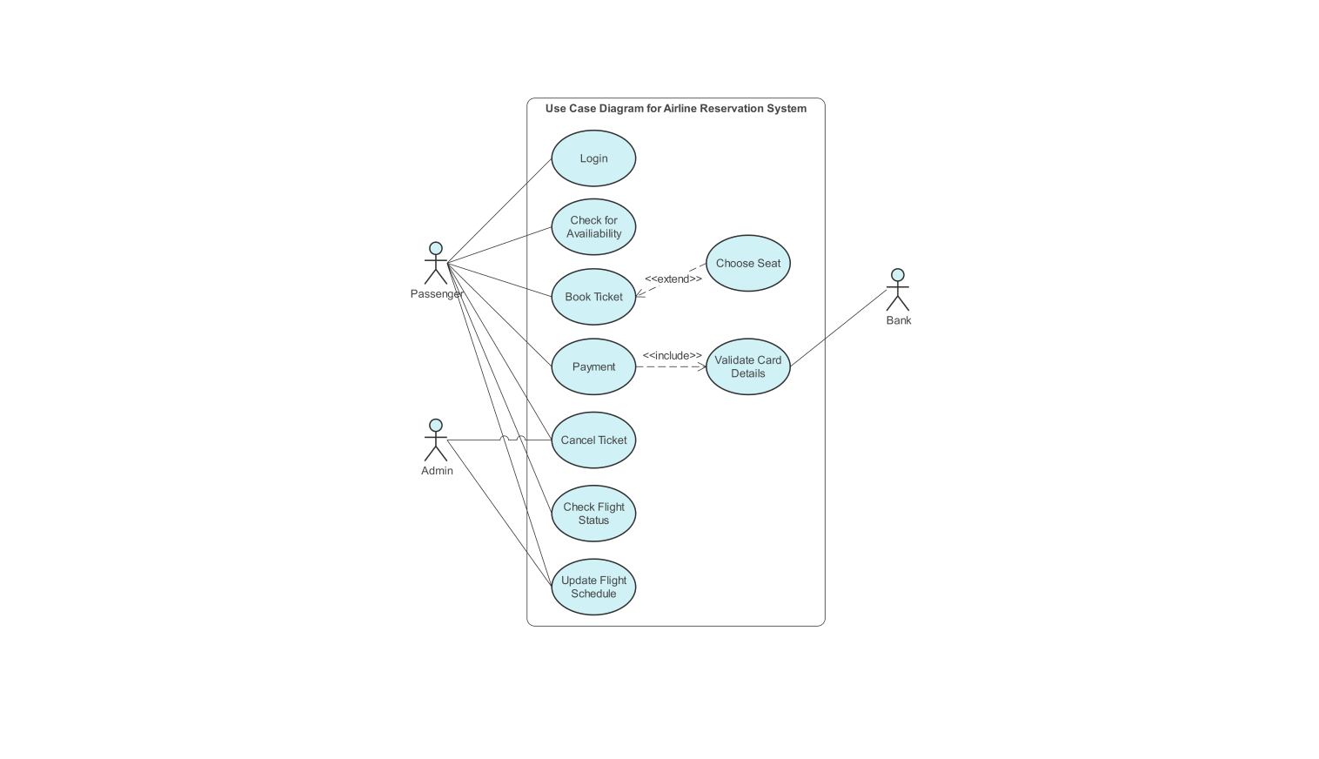

4.4.1Fig Use Case diagram

.

Fig4.4.1.1 Use Case diagram for system

Description:
The above diagram Represents interactions between Users, Business Owners, and the
CI/CD System, focusing on portfolio exploration, cost estimation, an automated deployment via GitHub Actions and Render.

      - Use Case Template for Acquiring Event Requirements

Use Case Name | Acquire Event Requirements
Participating Actors | User, System (MomentO Platform)
Flow of Events | - User enters event details such as date, location, number of guests, preferences.  - System validates the input data and processes the request.  - System stores the event requirements in the MongoDB database.
Entry Condition | User must fill in all required event details in the form.
Exit Condition | Event requirements are successfully stored and ready for further processing (booking and cost estimation).

      - Use Case Template for Exploring Event Options

Use Case Name | Explore Event Options
Participating Actors | Explore Event Options
Flow of Events | User browses different event categories such as weddings, parties, and corporate events.  System displays event packages, images, and details in a categorized manner.
Entry Condition | User must access the platform.
Exit Condition | User has successfully explored and selected event options.

Use Case Template for Cost Estimation

Use Case Name | Cost Estimation
Participating Actors | User, System (MomentO Platform)
Flow of Events | - User enters event details such as number of guests, event type, and preferences.  2. System calculates the estimated event cost using the budget calculator.
Entry Condition | User must provide required inputs for cost estimation.
Exit Condition | Estimated cost is successfully calculated and displayed to the user

      - Use Case Template for Admin Data Updates

Use Case Name | Admin Data Update
Participating Actors | Admin, System (MomentO Platform)
Flow of Events | - Admin logs in to the dashboard to manage data.  - Admin updates event details, user information, or booking status.
Entry Condition | Admin must provide valid update details and be authenticated.
Exit Condition | Platform data is successfully updated and reflected in the system.

7.2 Use Case Template for CI/CD System Interactions

Use Case Name | Fetch and Deploy Updates
Participating Actors | Admin, CI/CD System (GitHub Actions)
Flow of Events | - Admin makes changes to the application code or content.  - System pushes the updated code to the GitHub repository.  - CI/CD pipeline automatically builds and deploys the updated application.
Entry Condition | Admin must initiate and push updates to the repository.
Exit Condition | Updated version of the MomentO platform is successfully deployed and live.

4.4.2Class Diagram
The class diagram is the main building block of object-oriented modeling. It is used both for general conceptual modeling of the systematic of the application for detailed modeling translating the models into programming code. Class diagrams can also be used for data modeling. The classes in a class diagram represent both the main objects, interactions in the application and the classes to be programmed. A class with three sections

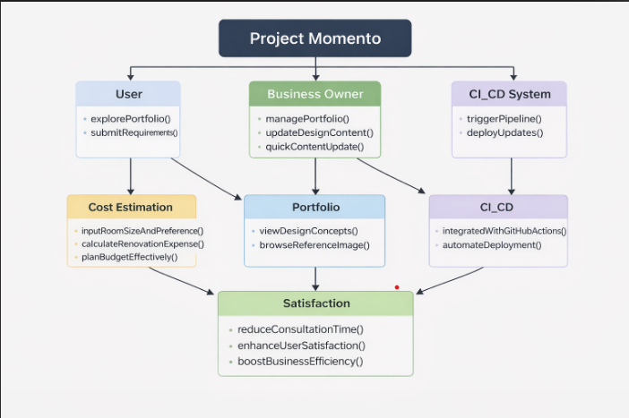

Fig 4.4.2. Class diagram for system

Description:

The above diagram Defines system structure with key classes like User, Web Application,
Cost Estimation, and CI/CD, ensuring seamless content updates and automated deployments.

Sequence Diagram
Sequence diagrams show the order of messages that are passed between elements of a system to complete a particular task or use case. The events that cross system boundaries are used by objects and people (actors) to complete their processes.
Graphical Notation: In a Sequence diagram, classes and actors are listed as columns, with vertical lifelines indicating the lifetime of the object over time.

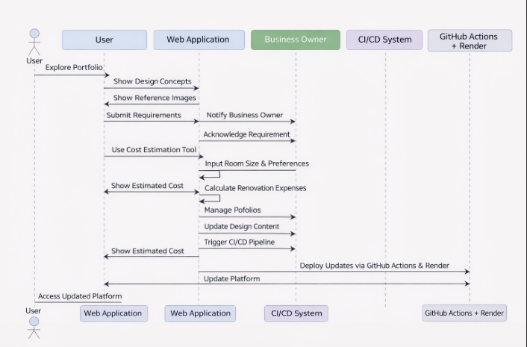

Fig4.4.3. Sequence diagram for system

Description:

The above diagram Illustrates the step-by-step interaction flow, from user actions to CI/CD pipeline execution, ensuring automated updates via GitHub Actions and Render.

Collaboration Diagram
A Collaboration diagram is easily represented by modeling objects in a system and representing the associations between the objects as links. The interaction between the objects is denoted by arrows. To identify the sequence of invocation of these objects, a number is placed next to each of these arrows. A

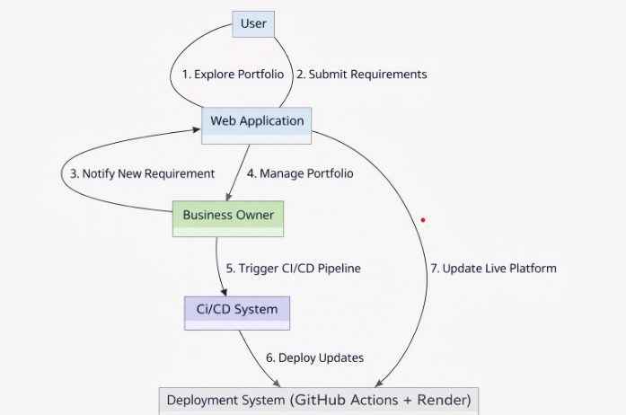

Fig4.4.4. Collaboration diagram for system Description:
The above diagram Shows object interactions where users submit requests, business owners manage content, and CI/CD automates deployments, making the system efficient and scalable.

Activity Diagram
The flow of events are shown within the system through these activity diagrams. These diagrams, simply put, are representations of flow control from one activity to another activity. The movement can be sequential, concurrent or branched. We describe how an activity occurs using activity diagrams.

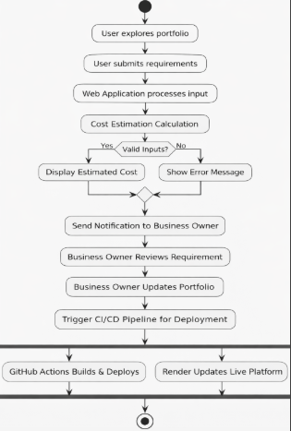

Fig4.4.5. Activity diagram for system

Description:

The above diagram Maps the workflow from portfolio exploration to deployment, ensuring a smooth, automated process with minimal manual intervention.

CHAPTER 5 TECHNOLOGY DESCRIPTION

1.TECHNOLOGY DESCRIPTION

5.1. Introduction to React js:

React.js is a widely used JavaScript library designed to build interactive and efficient user interfaces, especially for single-page applications (SPAs). Created and maintained by Facebook, React makes the development process smoother by using a component-based structure. This means that instead of writing repetitive code, developers can break down the UI into smaller, reusable components, making the codebase more organized and easier to manage. One of the best things about React is its declarative approach, which helps in creating user interfaces that automatically update when the underlying data changes, making applications feel more responsive and dynamic.
A key feature that sets React apart is the Virtual DOM (Document Object Model). Normally, updating the DOM directly can slow down a web application, but React solves this issue by using a virtual representation of the DOM. When data changes, React compares the new virtual DOM with the previous version and updates only the elements that actually need to change. This makes rendering faster and improves overall performance, which is crucial for applications that involve frequent user interactions—like the Wish Wings, where real-time updates can enhance the user In Wish Wings, React.js is used to build the entire frontend application including the animated Wings Intro splash screen, three separate dashboard interfaces for Users, Agents, and Admins, the package browsing and booking flow, and the real-time agent tracking interface. React’s Context API manages global authentication state across all three user roles without the need for Redux.
Key Features of React.js used in Wish Wings:
- JSX (JavaScript XML) – Allows writing HTML-like code within JavaScript for component templates.
- Component-Based Architecture – Reusable components like PackageCard, Navbar, Footer, and ProtectedRoute.
- React Hooks (useState, useEffect, useContext) – Manage state, side effects, and global context.
- React Router DOM – Enables client-side routing with role-based protected routes.
- Framer Motion Integration – Powers the WingsIntro animation and page transition effects.

Advantages of React.js
Reusable Component-Based Architecture – React promotes modular development by breaking the UI into reusable components, making applications more maintainable and reducing code duplication.

Optimized Performance with Virtual DOM – Instead of updating the actual DOM directly, React efficiently updates only the necessary parts using a Virtual DOM, improving rendering speed and responsiveness.
Declarative and Predictable UI – React’s declarative approach simplifies UI development, ensuring that interfaces update dynamically based on data changes, making debugging easier.
Efficient State Management – With built-in hooks like useState and useEffect, managing state within components is simpler. For complex applications, state management tools like Redux or Context API enhance data flow and scalability.
SEO-Friendly with Server-Side Rendering (SSR) – React, when combined with Next.js, supports server-side rendering, improving search engine optimization (SEO) and faster initial page loads.
Cross-Platform Development with React Native – Developers can use React Native to build mobile applications for both iOS and Android with a shared codebase, saving development time.
Unidirectional Data Flow for Better Control – React follows a one-way data binding approach, making it easier to track and manage state changes, reducing unexpected bugs.


Key Features of React.js
JSX (JavaScript XML) – React utilizes JSX, a syntax extension that allows developers to write HTML-like code within JavaScript, improving code readability and maintainability.
Component-Based Architecture – React applications are structured using reusable components, making development more modular, scalable, and efficient.
Props for Data Flow – Components can pass data to each other using props, enabling dynamic and flexible UI updates.
Hooks (use State, use Effect, etc.) – React provides built-in hooks to manage state and side effects within functional components, eliminating the need for class components.
React Router for Navigation – Enables smooth navigation in single-page applications (SPAs) by providing client-side routing and dynamic page transitions.
Optimized Rendering with React Fiber – React’s core algorithm, Fiber, improves the reconciliation process, ensuring faster and more efficient UI updates.

5.2 Introduction to VS Code:

Visual Studio Code (VS Code) has become one of the most popular code editors due to its lightweight nature, speed, and flexibility. Unlike heavier Integrated Development Environments (IDEs), VS Code offers the perfect balance between performance and functionality, making it ideal for developers who want to focus on writing code without unnecessary distractions. The editor's minimalistic yet highly efficient interface ensures that developers can easily navigate through their projects while still having access to powerful tools.

One of VS Code's standout features is its vast extension marketplace. Developers can enhance the editor with extensions for a variety of programming languages, tools, frameworks, and integrations with services like Docker, Kubernetes, and Azure. Whether you’re building a web application with React, Node.js, or Angular, or developing mobile applications with Flutter or React Native, there's an extension to help streamline the development process.
Another notable feature of VS Code is its Live Share capability, which allows real-time collaboration between developers. This feature makes remote pair programming easier by allowing multiple developers to work together on the same codebase simultaneously, sharing their sessions, terminals, and debugging sessions.
VS Code also supports a range of debugging tools. Whether you’re working on front-end JavaScript, back-end server-side applications, or full-stack projects, you can debug directly within the editor using breakpoints, variable inspection, and call stacks, all within a user-friendly interface. Additionally, VS Code supports version control with integrated Git, allowing you to track changes, commit code, and manage branches without leaving the editor.

Features of visual studio:
Lightweight and Fast – Unlike full-fledged IDEs, VS Code is lightweight and optimized for performance, making it ideal for both small and large projects.
IntelliSense – Provides smart code completions, syntax highlighting, and suggestions based on variable types, functions, and imported modules, improving coding efficiency.
Built-in Git Integration – Comes with built-in support for Git, allowing developers to clone repositories, commit changes, manage branches, and resolve merge conflicts without leaving the editor.

Extensive Extension Marketplace – Supports thousands of extensions for different languages, frameworks, themes, and tools, enabling developers to customize their workspace.
Integrated Terminal – Allows developers to execute commands directly within VS Code without switching to an external terminal, improving workflow efficiency.
Debugging Tools – Includes built-in debugging capabilities with breakpoints, watch variables, call and step-through debugging for JavaScript, Python, C++, and more.
Live Share for Collaboration – Enables real-time collaboration, allowing multiple developers to edit and debug the same code remotely.
Multi-Language Support – Provides native support for JavaScript, Python, C++, Java, HTML, CSS, and many other programming languages.
Customizable Interface – Offers themes, icons, layouts, and keyboard shortcuts that can be personalized to match a developer’s preferences.
Code Snippets and Shortcuts – Supports predefined and custom code snippets, making repetitive tasks faster and increasing developer productivity.
Settings Sync – Synchronizes preferences, extensions, themes, and settings across multiple devices using a Microsoft or GitHub account.

5.12 Introduction to CSS:
CSS, or Cascading Style Sheets, is a styling language used for describing the presentation and layout of web pages. It is one of the core technologies used for building web pages along with HTML and JavaScript.

Here are some of the key features of CSS:

Separation of presentation and content:

With CSS, web developers can separate the presentation of a web page (i.e., how it looks) from its content (i.e., what it says). This makes it easier to maintain and update the design of a website without changing its content.
Cascading:
CSS styles can be cascaded, meaning that multiple styles can be applied to an element, and the browser will use the most specific style rule to determine the final appearance of the element.

Selectors:
CSS allows developers to use selectors to target specific HTML elements on a web page and apply styles to them. Selectors can be based on the element's type, class, ID, or other attributes.
Layout control:
CSS provides developers with a wide range of layout control options, such as positioning, floats, and flexbox, that allow them to create complex and responsive layouts.
Cross-browser compatibility:
CSS is supported by all modern web browsers, making it a reliable and consistent way to style web pages.
Overall, CSS is a powerful tool for web developers that allows them to create visually appealing and responsive websites that can adapt to different screen sizes and devices.
5.13 Introduction to Node.js:
Node.js is a versatile, open-source, and cross-platform JavaScript runtime environment that enables developers to execute JavaScript code outside the browser. Powered by Chrome’s V8 engine, Node.js is designed for asynchronous, event-driven programming, making it an excellent choice for developing scalable and high-performance applications.
One of the standout features of Node.js is its non-blocking, single-threaded architecture, which allows it to handle multiple concurrent requests efficiently. This makes it particularly well-suited for real-time applications such as chat platforms, APIs, live streaming services, and collaborative tools.
Another major advantage of Node.js is its built-in npm (Node Package Manager), which provides developers with access to a vast ecosystem of open-source libraries and modules. This simplifies the development process by reducing redundant coding and enabling rapid prototyping. In backend development, Node.js is often paired with frameworks like Express.js to create RESTful APIs and microservices, making it a popular choice for modern web applications.
Due to its lightweight nature, speed, and efficiency, Node.js has become a go-to solution for building fast, scalable, and data-intensive applications. Its widespread adoption in the tech industry, combined with strong community support and continuous updates, ensures that it remains a reliable and future-proof technology for web development.

Key Features of Node.js
- Asynchronous and Non-Blocking – Node.js follows a non-blocking, event-driven architecture, meaning it can handle multiple requests simultaneously without waiting for one to finish before starting another.
- Single-Threaded with Event Loop – Uses a single-threaded model with an event loop, making it highly efficient for handling concurrent requests.
- Cross-Platform Compatibility – Runs on Windows, macOS, and Linux, making it versatile for various development environments.
- Fast Execution – Node.js is built on the V8 engine, which compiles JavaScript into machine code, improving execution speed.
- npm (Node Package Manager) – Comes with a package manager that provides access to thousands of reusable libraries and modules.
- Scalability – Suitable for microservices architecture, allowing developers to scale applications horizontally and vertically.
- Built-in HTTP Module – Includes built-in modules for handling HTTP requests, making it ideal for building APIs and web servers.
- Streams for Efficient Data Handling – Uses streams to handle large amounts of data efficiently, reducing memory usage.



Advantages of Node.js
Asynchronous and Non-Blocking – Node.js follows a non-blocking I/O model, allowing multiple operations to execute simultaneously without waiting for one to complete before moving to the next. This enhances efficiency, making it perfect for real-time applications.
Fast Performance – Built on Google Chrome’s V8 JavaScript engine, Node.js compiles JavaScript into machine code, resulting in faster execution speed. This makes it ideal for handling large-scale applications.

Single-Threaded with Event Loop – Unlike traditional multi-threaded servers, Node.js operates on a single-threaded event-driven architecture, efficiently managing multiple concurrent requests with minimal resource usage.
Lightweight and Scalable – Node.js is designed to handle high traffic loads while consuming fewer server resources, making it highly scalable for microservices and cloud-based applications.
Full-Stack JavaScript Development – With Node.js, developers can use JavaScript for both frontend and backend, streamlining the development process and reducing the need for multiple programming languages.

Large Ecosystem with npm (Node Package Manager) – Node.js comes with npm, which offers access to over a million open-source libraries and modules, accelerating development and reducing repetitive coding.
Ideal for Real-Time Applications – Node.js is widely used for chat applications, gaming platforms, live streaming, and collaborative tools due to its ability to handle real-time bidirectional communication using Web Sockets.
Microservices and API Development – Node.js is an excellent choice for building RESTful APIs and microservices, making it a preferred backend solution for modern web and mobile applications.
Cross-Platform Compatibility – Node.js supports Windows, macOS, and Linux, allowing developers to create cross-platform applications with minimal configuration.
Active Community and Strong Corporate Support – With backing from tech giants like Google, Microsoft, and PayPal, along with a large open-source community, Node.js is continuously evolving with regular updates and security enhancements.

Introduction to AWS (Amazon Web Services)
Amazon Web Services (AWS) is a leading cloud computing platform developed by Amazon that provides a vast range of on-demand cloud services such as computing power, storage, databases, networking, machine learning, security, and more. Launched in 2006, AWS has grown into the most widely used cloud service provider, serving millions of customers worldwide, from startups to large enterprises.
AWS enables businesses and developers to build, deploy, and manage applications without needing to invest in physical infrastructure. Its scalability, flexibility, and cost-effectiveness make it an ideal choice for hosting websites, running machine learning models, managing databases, and deploying enterprise applications.
With data centers spread across multiple regions worldwide, AWS ensures high availability, security, and performance for businesses. Whether it’s powering global platforms like Netflix, Airbnb, and NASA or supporting small-scale applications, AWS continues to revolutionize cloud computing by offering a secure, reliable, and innovative cloud environment.



Advantages of AWS (Amazon Web Services)

1. Scalability & Flexibility
- AWS enables businesses to scale resources up or down based on demand.
- Features like Auto Scaling and Elastic Load Balancing help maintain efficiency during traffic fluctuations.

2. Cost-Effectiveness
- Pay-as-you-go pricing ensures users only pay for the resources they consume.
Eliminates the need for upfront hardware investments, reducing operational expenses.
- The AWS Free Tier allows startups and developers to explore services at no initial cost.

3. High Availability & Reliability
- AWS operates in multiple global regions, each with Availability Zones (AZs) to prevent service disruptions.
- Backup & Disaster Recovery solutions safeguard data integrity and ensure business continuity.

4. Security & Compliance
- AWS offers advanced security tools such as AWS IAM (Identity & Access Management), AWS Shield (DDoS protection), and AWS WAF (Web Application Firewall).
- Meets industry compliance standards like GDPR, HIPAA, PCI DSS, and ISO 27001, ensuring robust data protection.

5. Extensive Service Offerings
- AWS provides 200+ fully managed cloud services, covering compute, storage, databases, machine learning, analytics, IoT, and more.
- Key services include Amazon EC2 (virtual servers), AWS Lambda (serverless computing), Amazon S3 (storage), and Amazon RDS (managed databases).

Introduction to MongoDB:
MongoDB is a widely used, open-source NoSQL database designed to manage large amounts of unstructured and semi-structured data efficiently. Unlike traditional relational databases that store information in tables with fixed schemas, MongoDB adopts a flexible, document-based approach where data is stored in JSON-like BSON format. This structure enables faster data retrieval, easy modification, and seamless scalability, making it ideal for modern applications.

Developed by MongoDB Inc., this database is known for its speed and adaptability, particularly in handling dynamic data structures. It is commonly used in applications that require real-time data processing, such as content management systems, e-commerce platforms, IoT solutions, and big data analytics. Its schema-less nature allows developers to modify data models effortlessly without disrupting existing functionality.
MongoDB is a popular choice for full-stack development, often paired with Node.js as part of the MERN stack (MongoDB, Express.js, React.js, Node.js) to build dynamic and scalable web applications. Additionally, it integrates well with cloud platforms like AWS, Google Cloud, and Azure, making deployment and scaling more efficient for better result.



Advantages ofMongoDB 1. Flexible Schema Design
o Unlike relational databases, MongoDB does not enforce a fixed schema, allowing developers to store various data structures within the same collection. o Ideal for dynamic applications like content management systems, e-commerce platforms, and applications that require frequent schema modifications.

2.Scalability & High Performance
- Supports horizontal scaling (sharding), enabling large datasets to be distributed efficiently across multiple servers.
- Ensures fast data processing, making it highly suitable for big data applications and real-time analytics.

Optimized Data Retrieval & Query Performance
o Uses BSON (Binary JSON) format, which enhances data storage and retrieval speed. o Advanced indexing mechanisms boost search performance, reducing query execution time significantly.
- Flexible NoSQL Structure
o Uses a document-based model, simplifying the management of complex, hierarchical data structures. o Supports embedded documents, eliminating the need for expensive relational joins and improving performance.

3. Seamless Integration with Modern Tech Stacks
o Works efficiently with Node.js, Python, Java, and other programming languages, making it versatile for different development environments. o A preferred choice for full-stack development, especially with the MERN stack (MongoDB, Express.js, React.js, Node.js).
- Automatic Sharding for Efficient Data Distribution
o Distributes data automatically across multiple servers using sharding, ensuring optimal performance and load balancing.
o Useful for applications that require high availability and low-latency data access.

5.Cloud Compatibility & Multi-Platform Support
- Easily deployable on cloud platforms like AWS, Google Cloud, and Azure, allowing smooth scalability and remote data management.
- Provides MongoDB Atlas, a fully managed cloud database service for easy setup and maintenance.

With the rise of mobile devices, responsive design is essential. CSS frameworks like
Bootstrap and Tailwind CSS make it easier to build mobile-friendly layouts. Example of a media query:
@media (max-width: 600px) { body {
background-color: lightgray;
}
}

JavaScript (JS)

What is JavaScript?

JavaScript is a high-level, interpreted programming language that adds dynamic behavior to websites. It enables real-time interactions, such as form validation, animations, and API calls.

Example of JavaScript:

document.getElementById("demo").innerHTML = "Hello, JavaScript!";

Key Features of JavaScript

- Client-Side Scripting: Runs in the user's browser for fast interactions.
- DOM Manipulation: Modifies webpage content dynamically.
- Event Handling: Responds to user actions like clicks and keypresses.
- Asynchronous Programming: Handles API calls without freezing the page.
- Modern ES6 Features: Includes let, const, arrow functions, and template literals.

JavaScript Frameworks & Libraries

JavaScript has a vast ecosystem of frameworks:

  - React.js – A component-based UI library for building dynamic interfaces.
  - Vue.js – A progressive framework with simple syntax and flexibility.

  - Node.js (Express.js) – Enables server-side scripting for full-stack applications.

Introduction to Vue.js What is Vue.js?
Vue.js is a progressive JavaScript framework used for building user interfaces and single-page applications (SPAs). It is designed to be incrementally adoptable, meaning developers can use it for simple UI enhancements or build fully-fledged web applications. Vue.js is widely known for its ease of use, flexibility, and powerful ecosystem, making it a popular choice among frontend developers.

Vue.js follows a component-based architecture, where the application UI is broken down into reusable components, making development more efficient and maintainable. It allows for declarative rendering using a template syntax and provides built-in reactivity, making state management seamless.

Key Features of Vue.js

Reactivity System: Vue.js has a powerful reactivity system that updates the DOM efficiently when the underlying data changes.

Component-Based Architecture: Applications are composed of modular, reusable components that help organize code and improve maintainability.

Virtual DOM: Vue.js uses a virtual DOM to optimize rendering performance by updating only the necessary components instead of re-rendering the entire page.

Two-Way Data Binding: The v-model directive allows easy synchronization between the UI and the underlying data.

Directives and Event Handling: Vue.js provides built-in directives like v-for, v- if, and v-bind to simplify DOM manipulation.

Vue Router: Enables seamless navigation in SPAs with features like route guards and lazy loading.

Vuex (State Management): A centralized state management solution for handling complex application states.

Easy Integration: Vue.js can be integrated into existing projects gradually, making it suitable for both new and legacy applications.

Lightweight & Fast: Vue.js is a lightweight framework with optimized performance, making it a great choice for building fast web applications.

Rich Ecosystem & Community Support: Vue.js has a well-documented ecosystem with tools like Vue CLI, Vue DevTools, and Nuxt.js for server-side rendering.

Vue.js vs Other Frameworks

Vue.js is often compared with other frontend frameworks like React.js and Angular. Here‟s how it stands out:

- Compared to React.js: Vue.js provides built-in state management and a more structured approach, while React relies on third-party libraries like Redux for state management.
- Compared to Angular: Vue.js is simpler and lighter than Angular, making it easier to learn and faster to develop with.

Example of a Simple Vue.js Component

Below is a basic example of a Vue.js component that displays a message dynamically:

<template>
<div>
<h1>{{ message }}</h1>
<button @click="updateMessage">Click Me</button>
</div>
</template>

<script>
export default { data() {

return {
message: "Hello, Vue.js!"
};
},
methods: { updateMessage() {
this.message = "You clicked the button!";
}
}
};
</script>

Introduction to Node.js

What is Node.js?

Node.js is an open-source, cross-platform JavaScript runtime environment that allows developers to execute JavaScript code outside of a web browser. It is built on the V8 JavaScript engine, which powers Google Chrome, and enables server-side development using JavaScript.

Node.js is widely used for building scalable, high-performance applications, including web servers, APIs, real-time applications, and microservices. Its non-blocking, event- driven architecture makes it efficient for handling multiple concurrent connections.

Key Features of Node.js

Asynchronous and Event-Driven: Node.js uses a non-blocking, event-driven architecture, making it suitable for scalable applications.

Single-Threaded Model: Uses a single-threaded event loop to handle multiple connections efficiently.

Fast Execution: Built on the V8 engine, Node.js executes JavaScript code quickly and efficiently.

NPM (Node Package Manager): Provides access to a vast ecosystem of open- source libraries and modules.

Cross-Platform Compatibility: Supports Windows, macOS, and Linux environments.

Built-in Modules: Comes with various modules for handling file systems, networking, and more.

RESTful APIs and Microservices: Ideal for building APIs and microservices architecture.

WebSockets and Real-Time Applications: Enables real-time data exchange, making it popular for chat applications and streaming services.

Scalability: Designed to handle large numbers of concurrent connections efficiently.

Community Support: A strong developer community continuously contributes to its growth and improvement.

Node.js vs Other Technologies

Node.js is often compared with other backend technologies like Python, Ruby, and Java. Here‟s how it stands out:

- Compared to Python: Node.js is faster for real-time applications, while Python is preferred for data-heavy applications.
- Compared to Ruby on Rails: Node.js offers better performance and scalability, whereas Rails provides faster development with conventions.
- Compared to Java: Node.js is lightweight and event-driven, while Java is preferred for enterprise-level applications.

Example of a Simple Node.js Server

Below is a basic example of a Node.js server using the built-in HTTP module:

const http = require('http');
const server = http.createServer((req, res) => { res.writeHead(200, { 'Content-Type': 'text/plain' }); res.end('Hello, Node.js!');
});
server.listen(3000, () => {
console.log('Server running at http://localhost:3000');
});

Introduction to Email API (EmailJS)

What is EmailJS?

EmailJS is a cloud-based email service that allows developers to send emails directly from the client-side of a web application without requiring a dedicated backend server. It eliminates the need for complex SMTP configurations, making email integration simple and efficient. By leveraging EmailJS, developers can send transactional emails, form submissions, and notifications seamlessly within their web applications.

EmailJS connects to various email service providers, including Gmail, Outlook, Yahoo, and custom SMTP servers, allowing for flexible email-sending options. It supports dynamic email templates, ensuring personalized and professional email communication without requiring extensive backend logic.

Key Features of EmailJS

No Backend Required: Enables sending emails directly from the frontend without a server-side email handler.

Multiple Email Service Providers: Supports Gmail, Outlook, Yahoo, and custom SMTP configurations.

Predefined Email Templates: Allows customization of email templates with dynamic placeholders.

Secure API with Authentication: Uses API keys for secure email transactions and prevents unauthorized access.

Seamless Integration with JavaScript Frameworks: Compatible with React.js, Vue.js, Angular, and other frontend technologies.

Automated Form Submissions: Easily integrates with HTML forms to send user responses via email.

REST API & JavaScript SDK: Provides an intuitive API and SDK for simplified email handling.

Real-Time Email Tracking: Allows tracking of sent emails with delivery status updates.

Spam Protection: Ensures high deliverability by reducing the chances of emails being marked as spam.

Cost-Effective Plans: Offers free and paid plans based on email-sending requirements.

How EmailJS Works

- Create an EmailJS Account: Sign up on EmailJS and obtain an API key.
- Connect an Email Service Provider: Link your email provider, such as Gmail or Outlook.
- Define an Email Template: Create a customizable template with placeholders for dynamic content.
- Integrate EmailJS in Your Application: Use EmailJS SDK or API in your frontend project.
- Trigger Email Sending: Call the EmailJS API with relevant data to send emails from the client-side.

Example: Sending an Email with EmailJS in JavaScript

Below is a simple example demonstrating how to send an email using EmailJS:

import emailjs from 'emailjs-com';

const sendEmail = () => { emailjs.send("service_id", "template_id", { from_name: "Your Name",
to_name: "Recipient Name", message: "Hello, this is a test email!"
}, "user_api_key")
.then(response => {
console.log("Email sent successfully!", response.status, response.text);
})
.catch(error => {
console.error("Failed to send email:", error);
});
});

Introduction to GitHub Actions

What is GitHub Actions?

GitHub Actions is a powerful automation tool that enables developers to define, manage, and execute workflows directly within their GitHub repositories. It provides a CI/CD (Continuous Integration and Continuous Deployment) system that automates tasks such as building, testing, and deploying applications.

By using GitHub Actions, developers can create custom workflows using YAML configuration files, integrating seamlessly with GitHub repositories to trigger automated processes based on events like code pushes, pull requests, or scheduled tasks.

Key Features of GitHub Actions

Automation & CI/CD: Automates the building, testing, and deployment of applications.

Event-Driven Workflows: Triggers workflows based on GitHub events such as push, pull_request, issue, and schedule.

Custom & Predefined Actions: Offers a marketplace with thousands of prebuilt actions and allows users to create their own.

Matrix Builds: Supports parallel execution of workflows with different configurations.

Self-Hosted & GitHub-Hosted Runners: Provides flexibility in choosing the infrastructure for executing workflows.

Secrets & Environment Variables: Supports secure storage of credentials and environment-specific variables.

Integration with Third-Party Tools: Works seamlessly with cloud providers, container registries, and monitoring tools.

Multi-Platform Support: Supports Linux, macOS, and Windows-based workflows.

YAML-Based Workflow Configuration: Uses YAML syntax for easy-to-read workflow definitions.

Cost-Effective: Free for public repositories with usage limits for private repositories.

How GitHub Actions Works

Define a Workflow: Create a .github/workflows/ directory in your GitHub repository and add a YAML configuration file.

Set Up Triggers: Specify when the workflow should run (e.g., on push, pull_request, or on a schedule).

Define Jobs and Steps: Configure tasks to execute within the workflow.

Use Actions: Utilize predefined actions from the GitHub Actions Marketplace or create custom actions.

Run & Monitor Workflows: View workflow execution results in the GitHub Actions tab.

Example: GitHub Actions Workflow for a Node.js Project

The following example defines a workflow that runs tests on a Node.js project whenever code is pushed:

name: Node.js CI

on:
push:
branches: [main] pull_request:
branches: [main]

jobs:
test:
runs-on: ubuntu-latest

steps:
- name: Checkout Code uses: actions/checkout@v3

- name: Set up Node.js
uses: actions/setup-node@v3 with:
node-version: 16

- name: Install Dependencies run: npm install

- name: Run Tests run: npm test

Render Introduction

Introduction

Render is a modern cloud platform that enables developers to deploy web applications, APIs, databases, and static sites with minimal configuration. It simplifies deployment by automating infrastructure management, offering built-in CI/CD, and providing support for multiple programming languages and frameworks.

Unlike traditional cloud platforms like AWS, GCP, and Azure, Render provides a fully managed environment with automatic scaling, free SSL, and custom domains, making it an excellent choice for developers looking for a hassle-free deployment solution.

Key Features

Simple Deployment
  - Deploy applications directly from GitHub or GitLab with automatic updates on new commits.

Support for Multiple Languages & Frameworks
  - Works with Node.js, Python, Ruby, Go, PHP, and other major programming languages.

Fully Managed Infrastructure
  - Automates server setup, scaling, networking, and security.

Auto Scaling
  - Applications scale automatically based on traffic, ensuring high performance.

Built-in CI/CD
  - Continuous Integration and Deployment (CI/CD) ensures that every push to the repository triggers an automatic build and deployment.

SSL & Custom Domains
  - Provides free SSL certificates and allows custom domains for secure hosting.

Database Hosting
  - Offers managed PostgreSQL databases with automatic backups and scalability.

Docker Support
  - Supports deployment of containerized applications using Dockerfiles.

Serverless Functions
  - Allows developers to run serverless functions for lightweight backend processes.

Cost-Effective

- Provides a free tier for static sites and affordable pricing for web services and databases.

How Render Works

Render provides an easy-to-use interface that allows developers to deploy applications quickly without managing servers. The deployment process follows these steps:

Sign Up & Connect Repository
  - Create an account on Render and connect your GitHub or GitLab repository.

Choose a Service Type
  - Select the type of service you want to deploy:
    - Static Site
    - Web Service
    - Database
    - Docker Container

Configure Deployment Settings
  - Define environment variables, set build commands, and configure any required dependencies.

Deploy the Application
  - Render will automatically build and deploy the application from the linked repository.

Monitor & Scale
  - Use the Render dashboard to monitor logs, scale services, and adjust configurations as needed.

Example: Deploying a Node.js Application on Render

Step 1: Push the Project to GitHub

Ensure your Node.js application is stored in a GitHub repository.

Step 2: Create a Web Service on Render

- Log in to Render.
- Select "New Web Service" and connect your GitHub repository.

Step 3: Set the Build Command

Specify the command to install dependencies:

npm install

Step 4: Set the Start Command

Specify the command to run the application:

node server.js

Step 5: Click Deploy

- Render will automatically build and host your application.
- Once deployed, the application will be accessible via a custom URL provided by Render.

Introduction to Cloud Computing

What is Cloud Computing?

Cloud computing is a technology that enables users to access and store data, applications, and computing resources over the internet instead of relying on local computers or physical servers. It provides on-demand access to a shared pool of computing resources, such as servers, storage, databases, networking, software, and analytics, without requiring users to manage the underlying infrastructure.

Cloud computing allows businesses and individuals to scale resources as needed, optimize costs, and access applications from anywhere with an internet connection. This eliminates the need for expensive hardware and maintenance, making IT operations more flexible, cost-effective, and efficient.

Key Characteristics of Cloud Computing

On-DemandSelf-Service
Users can provision resources automatically without the need for human intervention.

BroadNetworkAccess
Cloud services are accessible from any device with an internet connection.

ResourcePooling
Cloud providers use a multi-tenancy model to serve multiple customers efficiently by dynamically allocating computing resources.

RapidElasticity
Resources can be scaled up or down dynamically based on demand, ensuring optimal performance and cost efficiency.

MeasuredService
Users pay only for the resources they consume, reducing unnecessary costs.

Types of Cloud Computing

Public Cloud
  - Services are hosted by third-party providers such as AWS, Azure, and Google Cloud and shared among multiple users.
  - Suitable for startups, small businesses, and enterprises needing

scalability and cost efficiency.
- Private Cloud
  - Resources are dedicated to a single organization, offering greater control, security, and customization.
  - Commonly used by businesses handling sensitive data and regulatory requirements.

Hybrid Cloud
  - A combination of public and private clouds, allowing organizations to balance flexibility and security.
  - Frequently used when businesses need to store sensitive data privately while leveraging public cloud scalability for other tasks.

Multi-Cloud

  - Involves using multiple cloud providers to avoid vendor lock-in and improve reliability and availability.
  - Enables organizations to choose the best services from different providers based on their needs.

Cloud Service Models

Cloud computing is categorized into three primary service models:

Infrastructure as a Service (IaaS)
  - Provides virtualized computing resources, such as servers, storage, and networking.

Examples: AWS EC2, Google Compute Engine, Microsoft Azure Virtual Machines.
- Platform as a Service (PaaS)
  - Offers development environments and tools for building applications without managing the underlying infrastructure.

Examples: Google App Engine, Microsoft Azure App Services, Heroku.
- Software as a Service (SaaS)
  - Delivers fully managed applications over the internet, allowing users to access software without installation.
  - Examples: Gmail, Dropbox, Microsoft Office 365, Salesforce

Benefits of Cloud Computing

Cost Efficiency
  - Eliminates the need for expensive on-premise infrastructure, reducing capital and operational expenses.

Scalability
  - Resources can be increased or decreased based on workload demand, ensuring optimal performance.

Accessibility
  - Services can be accessed from anywhere with an internet connection, supporting remote work and collaboration.

Security
  - Leading cloud providers offer robust security measures, including encryption, multi-factor authentication, and compliance certifications.

Automatic Updates
  - Cloud providers handle software and security updates, reducing maintenance efforts for users.

Disaster Recovery
  - Cloud backup and recovery solutions protect data from loss or damage, ensuring business continuity.

Popular Cloud Service Providers

Several companies provide cloud computing services with varying features and pricing models. The most popular ones include:

Amazon Web Services (AWS)
  - The largest cloud provider, offering a wide range of services including

computing, storage, networking, AI, and machine learning.
- Microsoft Azure
  - A cloud platform providing computing, AI, IoT, and enterprise solutions, widely used by businesses.

Google Cloud Platform (GCP)
  - Specializes in cloud computing, data analytics, and AI-driven services.

IBM Cloud, Oracle Cloud, DigitalOcean, and others
  - Offer specialized cloud solutions for enterprises and developers.

Example: Hosting a Web Application on AWS

Cloud computing makes web hosting simple and scalable. Below is an example of deploying a web application using AWS EC2 (Elastic Compute Cloud):

Steps to Deploy a Web Application on AWS

Create an AWS account
  - Sign up at AWS Console and log in.

Launch an EC2 instance
  - Choose an Amazon Machine Image (AMI), such as Ubuntu or Amazon Linux.

Configure a Web Server
  - Install Apache or Nginx to serve web content.
  - Example command for Apache:
- sudo apt update
- sudo apt install apache2 -y
- sudo systemctl start apache2
- sudo systemctl enable apache2

Deploy Application Files
  - Upload HTML, CSS, and JavaScript files to the server‟s root directory (e.g., /var/www/html/).

Assign a Domain and Enable HTTPS
  - Use AWS Route 53 to configure a domain.
  - Set up SSL/TLS certificates using AWS Certificate Manager for HTTPS security.

This process allows businesses to host scalable applications on AWS without investing in physical infrastructure.

Introduction to Tailwind CSS

What is Tailwind CSS?

Tailwind CSS is a utility-first CSS framework that enables developers to create modern and responsive designs quickly. Unlike traditional CSS frameworks such as Bootstrap, which provide pre-built components, Tailwind CSS offers a set of low-level utility classes that allow developers to style elements directly in HTML without writing custom CSS.

The utility-first approach of Tailwind CSS helps streamline the development process by eliminating the need for writing large stylesheets. Instead, developers can use predefined utility classes to apply styling directly to HTML elements. This approach makes the design process more efficient and ensures a consistent and maintainable user interface.

Tailwind CSS is widely used in modern web development due to its customizability, performance optimizations, and seamless integration with front-end frameworks like React, Vue, and Angular.

Key Features of Tailwind CSS

Utility-First Approach
Tailwind CSS provides small utility classes that allow developers to style elements directly in the HTML file without writing custom CSS.

Highly Customizable
Developers can configure styles using the tailwind.config.js file to match project requirements.

Responsive Design
Tailwind CSS includes built-in responsive breakpoints, making it easy to create

mobile-friendly layouts.

Performance Optimized
Unused styles are automatically removed in production using PurgeCSS, reducing file size and improving performance.

Flexbox & Grid Support
Tailwind provides utility classes for both Flexbox and CSS Grid, simplifying layout design.

Dark Mode Support
With a simple configuration, developers can easily implement dark mode in their applications.

Component-Friendly
Tailwind CSS works seamlessly with front-end frameworks like React, Vue, Angular, and more.

How Tailwind CSS Works

Instead of writing custom CSS rules, Tailwind CSS allows developers to use predefined utility classes directly in HTML to style elements.

Example: Without Tailwind CSS (Traditional CSS Approach)
<style>
.btn {
background-color: blue; color: white;
padding: 10px 20px; border-radius: 5px;
}
</style>

<button class="btn">Click Me</button>

Example: With Tailwind CSS
<button class="bg-blue-500 text-white px-4 py-2 rounded">Click Me</button>

In this example, instead of writing custom CSS rules, we use Tailwind's utility classes (bg-blue-500, text-white, px-4, py-2, rounded) to achieve the same styling directly in HTML.

Installing Tailwind CSS

There are multiple ways to add Tailwind CSS to your project:

Using a CDN (Quick Setup)

For quick prototyping, you can include Tailwind CSS using a CDN:

<link href="https://cdn.jsdelivr.net/npm/tailwindcss@2.2.19/dist/tailwind.min.css" rel="stylesheet">

This method is best suited for small projects and testing purposes.

Installing via npm (Recommended for Projects)

For better customization and maintainability, it is recommended to install Tailwind CSS using npm:

npm install -D tailwindcss postcss autoprefixer npx tailwindcss init

After installation, you can configure Tailwind CSS in the tailwind.config.js file to customize styles according to your project‟s requirements.

Example: Creating a Simple Card Using Tailwind CSS

Below is an example of a simple card component styled using Tailwind CSS.

<div class="max-w-sm mx-auto bg-white shadow-lg rounded-lg p-6">
<h2 class="text-xl font-bold text-gray-800">Tailwind CSS</h2>
<p class="text-gray-600">A utility-first CSS framework for rapid UI development.</p>
<button class="mt-4 bg-blue-500 text-white px-4 py-2 rounded">Learn More</button>
</div>

Explanation of Tailwind Classes Used:

- max-w-sm → Sets the maximum width of the card.
- mx-auto → Centers the card horizontally.
- bg-white → Sets the background color to white.
- shadow-lg → Applies a large shadow effect.
- rounded-lg → Rounds the corners of the card.
- p-6 → Adds padding inside the card.
- text-xl font-bold text-gray-800 → Styles the heading with size, weight, and color.
- text-gray-600 → Sets the paragraph text color.
- mt-4 bg-blue-500 text-white px-4 py-2 rounded → Styles the button with margin, background color, text color, padding, and rounded corners.

CHAPTER 6 SAMPLECODE

2.SAMPLECODE

Home.jsx

import React from "react";

const Hero = () => {
const navTo = (id) => document.getElementById(id)?.scrollIntoView({ behavior: "smooth" });

return (
<section id="home" className="hero-section">
<div className="hero-bg" />
<div className="hero-overlay" />
<div className="hero-content">
<div className="hero-eyebrow">✦ Premium Event Planning ✦</div>
<h1>We Make Your<br /><em>Moments Magical</em></h1>
<div className="hero-divider">
<span style={{ position:"absolute", left:-14, top:-6, color:"var(--gold)", fontSize:8 }}>◆</span>
<span style={{ position:"absolute", right:-14, top:-6, color:"var(--gold)", fontSize:8 }}>◆</span>
</div>
<p>Book your dream event with professional planning, curated vendors & premium services — all in one place.</p>
<button className="btn-primary" onClick={() => navTo("events")}>Explore Events</button>
</div>
<div className="scroll-hint">
<span>Scroll</span>
<div className="scroll-line" />
</div>
</section>
);
};

export default Home;

Admin.jsx

import React, { useState } from "react";
import { useApp } from "../../context/AppContext";
import { showToast } from "../Layout/Layout";
import API_BASE from "../../../config/api";

// =====================================================================
// ADMIN BOOKINGS SECTION — Drop this into your Admin.jsx
// Replace the existing {/* Bookings */} section with this component
// =====================================================================

const AdminBookings = ({ onOpenInvoice }) => {
const { bookings, setBookings } = useApp();
const [filterStatus, setFilterStatus] = useState("all");
const [search, setSearch] = useState("");

// ── Status change ──────────────────────────────────────────────────
const changeStatus = async (index, newStatus) => {
const booking = bookings[index];
if (!booking) return;

// Update local state immediately
const updated = [...bookings];
updated[index] = { ...updated[index], status: newStatus };
setBookings(updated);

// Show toast notification
showToast(
newStatus === "confirmed"
? "✓ Booking Confirmed"
: newStatus === "cancelled"
? "✗ Booking Cancelled"
: "⏳ Marked as Pending",
newStatus === "confirmed" ? "success" : "processing"
);

// Update in MongoDB via API
try {
console.log("🚀 Updating booking status in MongoDB...");
console.log("📦 Booking ID:", booking.id || booking._id);
console.log("📦 Booking ID type:", typeof booking.id, typeof booking._id);
console.log("📦 New Status:", newStatus);

const bookingId = booking.id || booking._id || booking.bookingId;
if (!bookingId) {
console.error("❌ No booking ID found!");
showToast("❌ Cannot update: No booking ID", "error");
return;
}

const res = await fetch(`${API_BASE}/bookings/${bookingId}`, {
method: "PUT",
headers: {
"Content-Type": "application/json"
},
body: JSON.stringify({ status: newStatus })
});

if (res.ok) {
const data = await res.json();
console.log("✅ Status updated in MongoDB:", data);
showToast("✓ Status saved to database", "success");
} else {
const errorData = await res.json();
console.error("❌ Failed to update status in MongoDB:", errorData);
showToast("⚠️ Status changed locally but not saved to database", "warning");
}
} catch (err) {
console.error("❌ Network error updating status:", err);
showToast("⚠️ Status changed locally. Server sync failed.", "warning");
}
};

// ── Cancel booking ─────────────────────────────────────────────────
const cancelBooking = (index, name) => {
if (window.confirm(`"${name}" booking cancel )) {
changeStatus(index, "cancelled");
}
};

// ── Delete booking ─────────────────────────────────────────────────
const deleteBooking = (index, name) => {
if (window.confirm(`"${name}" booking delete ?`)) {
setBookings((prev) => prev.filter((_, i) => i !== index));
showToast("✓ Booking deleted", "success");
}
};

// ── Filter + Search ────────────────────────────────────────────────
const filtered = bookings.filter((b) => {
const matchStatus = filterStatus === "all" || b.status === filterStatus;
const matchSearch =
b.name?.toLowerCase().includes(search.toLowerCase()) ||
b.event?.toLowerCase().includes(search.toLowerCase()) ||
b.id?.toLowerCase().includes(search.toLowerCase());
return matchStatus && matchSearch;
});

// ── Status badge color ─────────────────────────────────────────────
const statusColor = (s) =>
s === "confirmed"
? { color: "#4caf50", border: "1px solid rgba(76,175,80,.35)" }
: s === "cancelled"

? { color: "#f44336", border: "1px solid rgba(244,67,54,.35)" }

: { color: "var(--gold)", border: "1px solid rgba(201,168,76,.35)" };

const statusIcon = (s) =>
s === "confirmed" ? "✓" : s === "cancelled" ? "✕" : "⏳";

return (
<div style={{ marginTop: 32 }}>
{/* ── Header ── */}
<div
style={{
display: "flex",
justifyContent: "space-between",
alignItems: "center",
marginBottom: 16,
flexWrap: "wrap",
gap: 8,
}}
>
<h3
style={{
fontFamily: "'Cormorant Garamond',serif",
fontSize: 22,
fontWeight: 300,
color: "var(--gold)",
}}
>
◈ All Bookings
</h3>
<span style={{ fontSize: 11, color: "var(--text-muted)" }}>
{filtered.length} / {bookings.length} bookings
</span>
</div>

{/* ── Search + Filter Bar ── */}
<div
style={{
display: "flex",
gap: 10,
marginBottom: 16,
flexWrap: "wrap",
}}
>
{/* Search */}
<input
placeholder="🔍 Search by name, event, ID..."
value={search}
onChange={(e) => setSearch(e.target.value)}
style={{
flex: 1,
minWidth: 180,
background: "rgba(255,255,255,0.05)",
border: "1px solid rgba(201,168,76,.25)",
borderRadius: 8,
padding: "8px 12px",
color: "var(--text-main, #fff)",
fontSize: 12,
outline: "none",
}}
/>

{/* Filter Buttons */}
{["all", "confirmed", "pending", "cancelled"].map((s) => (
<button
key={s}
onClick={() => setFilterStatus(s)}
style={{
fontSize: 11,
padding: "8px 14px",
borderRadius: 20,
border:
filterStatus === s
? "1px solid var(--gold)"
: "1px solid rgba(201,168,76,.2)",
background:
filterStatus === s
? "rgba(201,168,76,.15)"
: "transparent",
color: filterStatus === s ? "var(--gold)" : "var(--text-muted)",
cursor: "pointer",
textTransform: "capitalize",
}}
>
{s}
</button>
))}
</div>

{/* ── Booking Cards ── */}
{filtered.length === 0 ? (
<div
style={{
textAlign: "center",
color: "var(--text-muted)",
padding: "40px 0",
fontSize: 13,
}}
>
No bookings found.
</div>
) : (
filtered.map((b, i) => {
// Find real index in original bookings array
const realIndex = bookings.indexOf(b);

return (
<div
key={b.id || i}
style={{
background: "rgba(255,255,255,0.03)",
border: "1px solid rgba(201,168,76,.12)",
borderRadius: 12,
padding: "16px 18px",
marginBottom: 12,
transition: "border-color 0.2s",
}}
>
{/* ── Top Row: ID + Status Badge ── */}
<div
style={{
display: "flex",
justifyContent: "space-between",
marginBottom: 8,
flexWrap: "wrap",
gap: 6,
alignItems: "center",
}}
>
<span
style={{
color: "var(--gold)",
fontSize: 11,
fontFamily: "monospace",
}}
>
{b.id}
</span>

{/* Status Badge — shows current status */}
<span
style={{
fontSize: 10,
padding: "3px 12px",
borderRadius: 20,
textTransform: "capitalize",
...statusColor(b.status),
}}
>
{statusIcon(b.status)} {b.status}
</span>
</div>

{/* ── Booking Details ── */}
<div
style={{
fontFamily: "'Cormorant Garamond',serif",
fontSize: 16,
marginBottom: 2,
}}
>
{b.name}
</div>
<div
style={{
fontSize: 12,
color: "var(--text-muted)",
marginBottom: 2,
}}
>
{b.event}
</div>
<div
style={{
fontSize: 12,
color: "var(--text-muted)",
marginBottom: 12,
}}
>
📅 {b.date} · ₹
{typeof b.price === "number"
? b.price.toLocaleString("en-IN")
: b.price}
</div>

{/* ── Action Buttons ── */}
<div
style={{
display: "flex",
gap: 8,
flexWrap: "wrap",
alignItems: "center",
}}
>
{/* Invoice */}
<button
className="btn-invoice"
onClick={() => onOpenInvoice(b.id)}
>
📄 Invoice
</button>

{/* Confirm Button — only show if not confirmed */}
{b.status !== "confirmed" && (
<button
onClick={() => changeStatus(realIndex, "confirmed")}
style={{
fontSize: 11,
padding: "8px 14px",
borderRadius: 8,
border: "1px solid rgba(76,175,80,.4)",
background: "rgba(76,175,80,.12)",
color: "#4caf50",
cursor: "pointer",
}}
>
✓ Confirm
</button>
)}

{/* Pending Button — only show if confirmed */}
{b.status === "confirmed" && (
<button
onClick={() => changeStatus(realIndex, "pending")}
style={{
fontSize: 11,
padding: "8px 14px",
borderRadius: 8,
border: "1px solid rgba(201,168,76,.4)",
background: "rgba(201,168,76,.12)",
color: "var(--gold)",
cursor: "pointer",
}}
>
⏳ Mark Pending
</button>
)}

{/* Cancel Button — only show if not cancelled */}
{b.status !== "cancelled" && (
<button
onClick={() => cancelBooking(realIndex, b.name)}
style={{
fontSize: 11,
padding: "8px 14px",
borderRadius: 8,
border: "1px solid rgba(244,67,54,.4)",
background: "rgba(244,67,54,.12)",
color: "#f44336",
cursor: "pointer",
}}
>
✕ Cancel
</button>
)}

{/* Delete Button */}
<button
onClick={() => deleteBooking(realIndex, b.name)}
style={{
fontSize: 11,
padding: "8px 14px",
borderRadius: 8,
border: "1px solid rgba(180,50,50,.3)",
background: "rgba(180,50,50,.08)",
color: "#c0392b",
cursor: "pointer",
marginLeft: "auto",
}}
>
🗑 Delete
</button>
</div>
</div>
);
})
)}
</div>
);
};

export default AdminBookings;

User Login:

import React, { useState, useEffect } from "react";
import { useApp } from "../../context/AppContext";
import API_BASE from "../../../config/api";
import { showToast } from "../Layout/Layout";

const UserAuth = ({ onOpenInvoice }) => {
const { loggedInUser, setLoggedInUser, logout: globalLogout, bookings, setBookings } = useApp();
const [tab, setTab] = useState("login");
const [form, setForm] = useState({ name:"", email:"", phone:"", password:"" });
const [error, setError] = useState("");
const [loading, setLoading] = useState(false);

const myBookings = bookings.filter(b => b.name === loggedInUser?.name);

// Load bookings from backend with retry logic
const loadBookings = async () => {
try {
console.log("🔄 Loading bookings from backend...");
const res = await fetch(`${API_BASE}/bookings`);
if (!res.ok) throw new Error("Failed to load bookings");
const allBookings = await res.json();
setBookings(allBookings);
} catch (err) {
console.error("❌ Failed to load bookings:", err);
}
};

const login = async () => {
if (!form.email || !form.password) { setError("✗ Email and password required"); return; }
setLoading(true);
setError("");
try {
const res = await fetch(`${API_BASE}/auth/login`, {
method: "POST",
headers: { "Content-Type": "application/json" },
body: JSON.stringify({ email: form.email, password: form.password })
});

const data = await res.json();
if (!res.ok) throw new Error(data.message || "Login failed");

localStorage.setItem("momento_user", JSON.stringify(data));
setLoggedInUser(data);
showToast(`✓ Welcome back, ${data.name}!`, "success");
} catch (err) {
setError(`✗ ${err.message}`);
} finally {
setLoading(false);
}
};

const register = async () => {
if (!form.name || !form.email || !form.phone || !form.password) { setError("✗ Fill all fields"); return; }
if (form.password.length < 6) { setError("✗ Password min 6 chars"); return; }
setLoading(true);
setError("");
try {
const res = await fetch(`${API_BASE}/auth/register`, {
method: "POST",
headers: { "Content-Type": "application/json" },
body: JSON.stringify(form)
});

const data = await res.json();
if (!res.ok) throw new Error(data.message || "Registration failed");

localStorage.setItem("momento_user", JSON.stringify(data));
setLoggedInUser(data);
showToast(`🎉 Welcome, ${data.name}!`, "confirmed");
} catch (err) {
setError(`✗ ${err.message}`);
} finally {
setLoading(false);
}
};

const logout = () => {
globalLogout();
setForm({ name:"", email:"", phone:"", password:"" });
setTab("login");
showToast("✓ Logged out", "");
};

const badge = (status) => {
const c = { pending:"#f0a500", confirmed:"#c9a84c", completed:"#4caf82", cancelled:"#e05a5a" };
return <span style={{ background:"rgba(201,168,76,.12)", border:`1px solid ${c[status]||"#c9a84c"}`, color:c[status]||"#c9a84c", fontSize:10, padding:"3px 10px", borderRadius:20 }}>{status}</span>;
};

return (
<section id="userAuth" className="userauth-section">
<div className="section-wrap">
<div className="section-label">My Account</div>
<h2 className="section-title">User <em>{loggedInUser ? "Dashboard" : "Login"}</em></h2>

{loggedInUser ? (
<div>
<div className="user-welcome">
<div className="user-avatar">{loggedInUser.name[0].toUpperCase()}</div>
<div className="user-welcome-text">
<h3>Welcome, {loggedInUser.name}!</h3>
<p>{loggedInUser.email}</p>
</div>
<button className="btn-close" style={{ marginLeft:"auto" }} onClick={logout}>Logout</button>
</div>
<div className="user-bookings-table">
<div className="user-bookings-head">
<h4>◈ My Bookings</h4>
<span style={{ fontSize:11, color:"var(--text-muted)" }}>{myBookings.length} bookings</span>
<button
style={{ marginLeft: "10px", fontSize: "10px", padding: "2px 8px" }}
onClick={loadBookings}
>
🔄 Refresh
</button>
</div>
<div className="booking-card-list">
{myBookings.length === 0 ? (
<div className="no-bookings">No bookings yet.</div>
) : myBookings.map((b, i) => (
<div key={i} className="booking-card">
<div className="bc-top"><span className="bc-id">{b.id?.slice(0, 8) || 'ID'}</span>{badge(b.status || 'confirmed')}</div>
<div className="bc-event">{b.event}</div>
<div className="bc-date">📅 {b.date}</div>
<div className="bc-phone">📞 {b.phone}</div>
<div className="bc-services">🎯 {b.services}</div>
<div className="bc-price">₹{typeof b.price === "number" ? b.price.toLocaleString("en-IN") : b.price}</div>
<div className="bc-actions">
<button className="btn-invoice" onClick={() => onOpenInvoice(b.id)}>📄 Invoice</button>
</div>
</div>
))}
</div>
</div>
</div>
) : (
<div style={{ maxWidth:420 }}>
<div className="auth-tabs">
{["login","register","forgot"].map(t => (
<button key={t} className={`auth-tab${tab === t ? " active" : ""}`} onClick={() => { setTab(t); setError(""); }}>
{t === "login" ? "Login" : t === "register" ? "Register" : "Forgot"}
</button>
))}
</div>
<div className="auth-box">
{tab === "login" && <>
<h3>◈ Welcome Back</h3>
<div className="auth-form-group"><label>Email</label><input type="email" placeholder="your@email.com" value={form.email} onChange={e => setForm({ ...form, email:e.target.value })} /></div>
<div className="auth-form-group"><label>Password</label><input type="password" placeholder="Enter password" value={form.password} onChange={e => setForm({ ...form, password:e.target.value })} /></div>
{error && <div className="auth-error show">{error}</div>}
<button className={`btn-primary ${loading ? 'loading' : ''}`} style={{ width:"100%" }} onClick={login} disabled={loading}>
{loading ? "Processing..." : "Login to My Account"}
</button>
<div style={{ textAlign:"center", marginTop:14, fontSize:12, color:"var(--text-muted)" }}>No account? <span style={{ color:"var(--gold)", cursor:"pointer" }} onClick={() => setTab("register")}>Register here</span></div>
</>}
{tab === "register" && <>
<h3>◈ Create Account</h3>
<div className="auth-form-group"><label>Full Name</label><input type="text" placeholder="Your full name" value={form.name} onChange={e => setForm({ ...form, name:e.target.value })} /></div>
<div className="auth-form-group"><label>Email</label><input type="email" placeholder="your@email.com" value={form.email} onChange={e => setForm({ ...form, email:e.target.value })} /></div>
<div className="auth-form-group"><label>Phone</label><input type="tel" placeholder="+91 98765 43210" value={form.phone} onChange={e => setForm({ ...form, phone:e.target.value })} /></div>
<div className="auth-form-group"><label>Password</label><input type="password" placeholder="Min 6 characters" value={form.password} onChange={e => setForm({ ...form, password:e.target.value })} /></div>
{error && <div className="auth-error show">{error}</div>}
<button className={`btn-primary ${loading ? 'loading' : ''}`} style={{ width:"100%" }} onClick={register} disabled={loading}>
{loading ? "Processing..." : "Create Account"}
</button>
</>}
{tab === "forgot" && <>
<h3>◈ Reset Password</h3>
<div className="auth-form-group"><label>Registered Email</label><input type="email" placeholder="your@email.com" value={form.email} onChange={e => setForm({ ...form, email:e.target.value })} /></div>
<button className="btn-primary" style={{ width:"100%" }} onClick={() => showToast("✅ Reset link sent (demo mode)", "success")}>Send Reset Link</button>
</>}
</div>
</div>
)}
</div>
</section>
);
};

export default UserAuth

CHAPTER 7 TESTING

TESTING

7.1 Testing Methodologies

In general, software engineers distinguish software faults from software failures. In the case of a failure, the software does not do what the user expects. A fault is a programming error that may or may not actually manifest as a failure. For Wish Wings, testing was conducted across all three user roles — User, Agent, and Admin — to ensure that the role-based access control, booking workflow, real-time tracking, and media upload features all function as specified.

Testing Techniques:

Black Box Testing: In this strategy, test cases are generated as input conditions that fully exercise all functional requirements of the Wish Wings application. This testing was used to verify correct booking creation, agent login restriction when isApproved is false, admin assignment workflow, and reaction vault upload functionality. Only the output is checked for correctness without examining internal logic.

White Box Testing: Test cases were generated based on the logic of each module by examining the controller code flow. This was used to verify JWT token generation, bcrypt password comparison, Socket.IO room joining logic, and Mongoose query filters that restrict agents to their assigned jobs only.

Testing Strategies:
- Unit Testing: Individual functions were tested in isolation. Each controller function (registerUser, createBooking, approveAgent, updateJobStatus) was verified to produce the correct output for valid and invalid inputs.

- Integration Testing: Combined backend components were tested to verify that the authentication middleware correctly gates route access, that booking creation triggers the email notification, and that agent approval by admin correctly updates the isApproved flag.

- System Testing: End-to-end testing verified that the complete booking workflow functions correctly from user signup through package browsing, booking submission, admin assignment, agent delivery, GPS tracking, and reaction vault upload.

- Functional Testing: All specified API endpoints were verified against their expected behavior for valid input, invalid input, missing authentication, and role violations.

System Testing and Implementation

The purpose is to exercise the different parts of the module code to detect coding errors. After this the modules are gradually integrated into subsystems, which are then integrated themselves too eventually forming the entire system. During integration of module integration testing is performed. The goal of this is to detect designing errors, while focusing the interconnection between modules. After the system was put together, system testing is performed. Here the system is tested against the system requirements to see if all requirements were met and the system performs as specified by the requirements. Finally accepting testing is performed to demonstrate to the client for the operation of

the system.
For the testing to be successful, proper selection of the test case is essential. There are two different approaches for selecting test case. The software or the module to be tested is treated as a black box, and the test cases are decided based on the specifications of the system or module. For this reason, this form of testing is also called “black box testing”.
Testing is an extremely critical and time-consuming activity. It requires proper planning of the overall testing process. Frequently the testing process Starts with the test plan. This plan identifies all testing related activities that must be performed and specifies the schedule, allocates the resources, and specifies guidelines for testing. The test plan specifies conditions that should be tested; different units to be tested, and the manner in which the module will be integrated together. Then for different test unit, a test case specification document is produced, which lists all the different test cases, together with the expected outputs, that will be used for testing. During the testing of the unit the specified test cases are executed and the actual results are compared with the expected outputs. The final output of the testing phase is the testing report and the error report, or a set of such reports. Each test report contains a set of test cases and the result of executing the code with the test cases. The error report describes the errors encountered and the action taken to remove the error.

Testing Techniques
Testing is a process, which reveals errors in the program. It is the major quality measure employed during software development. During testing, the program is executed with a set of conditions known as test cases and the output is evaluated to determine whether the program is performing as expected. In order to make sure that the system does not have errors, the different levels of testing strategies that are applied at differing phases of software development are:

Black Box Testing
In this strategy some test cases are generated as input conditions that fully execute all functional requirements for the program. This testing has been uses to find errors in the following categories:

- Incorrect or missing functions
- Interface errors
- Errors in data structure or external database access
- Performance errors
- Initialization and termination errors.
In this testing only the output is checked for correctness. The logical flow of the data is not checked.

White Box Testing

Testing Strategies
1.Unittesting

Unit testing involves the design of test cases that validate that the internal program logic is functioning properly, and that program inputs produce valid outputs. All decision branches and internal code flow should be validated. It is the testing of individual software units of the application. It is done after the completion of an individual unit before integration. This is a structural testing, that relies on knowledge of its construction and is invasive. Unit tests perform basic tests at component level and test a specific business process, application, and/or system configuration. Unit tests ensure that each unique path of a business process performs accurately to the documented specifications and contains clearly defined inputs and expected results.

This System consists of 3 modules. Those are Reputation module, route discovery module, audit module. Each module is taken as unit and tested.

Identified errors are corrected and executable unit are obtained.
2.Integration testing:
Integration tests are designed to test integrated software components to determine if they actually run as one program. Testing is event driven and is more concerned with the basic outcome of screens or fields. Integration tests demonstrate that although the components were individually satisfaction, as shown by successfully unit testing, the combination of components is correct and consistent. Integration testing is specifically aimed at exposing the problems that arise from the combination of components.
3.System Testing:
System testing ensures that the entire integrated software system meets requirements. It tests a configuration to ensure known and predictable results. An example of system testing is the configuration oriented system integration test. System testing is based on process descriptions and flows, emphasizing predriven process links and integration points.
4.Functional Testing:
Functional tests provide systematic demonstrations that functions tested are available as specified by the business and technical requirements, system documentation, and user manuals.
Functional testing is centered on the following items

1. Valid Input | : identified classes of valid input must accepted.
2. Invalid  Input | : identified classes of invalid input must rejected.
3. Functions | : identified functions must be exercised.
4. Output | : identified classes of application outputs
must be exercised.
5.Systems : Interfacing systems/procedures must be
invoked.
Organization nd preparation of functional tests is focused on requirements, key functions, or special test cases. In addition, systematic coverage pertaining to identify Business process flows; data fields, predefined processes, and successive processes.

7.2 Preparation of Test Data:
Taking various kinds of test data does the above testing Preparation of test data plays a vital role in the system testing. After preparing the test data the system under study is tested using that test data. While testing the system by using test data errors are again uncovered and corrected by using above testing steps and corrections are also noted for future use.
Live Test Data:
Live test data are those that are actually extracted from organization files. After a system is partially constructed, programmers or analysts often ask users to key in a set of data from their normal activities. Then, the systems person uses this data as a way to partially test the system in no the organic store for healthy veggies and fruits other instances, programmers or analysts extract a set of live data from the files and have them entered themselves, It is difficult to obtain live data in sufficient amounts to conduct extensive testing And, although it is realistic data that will show how the system will perform for the typical processing requirement, assuming that the live data entered are in fact typical, such data generally will not test all combinations or formats that can enter the system. This bias toward typical values then does not provide a true system test and in fact ignores the cases most likely to cause system failure.
Using Artificial Test Data:
Artificial test data are created solely for test purposes, since they can be generated to test all combinations of formats and values. In other words, the artificial data, which can quickly be prepared by a data generating utility program in the information systems department, make possible the testing of all login and control paths through the program. The most effective test
programs use artificial test data generated by persons other than those who wrote the programs. Often, an independent team of testers formulates a testing plan, using the systems specifications the package "Virtual Private Network" has satisfied all the requirements specified as per software requirement specification and was accepted. 12Whenever a new system is developed; user training is required to educate them about the working of the system so that it can be put to efficient use by those for whom the system has been primarily designed.
For this purpose, the normal working of the project was demonstrated to the prospective users. Its working is easily understandable and since the expected users are people who have good knowledge of computers, the use of this system is very easy. Maintenance This covers a wide range of activities including correcting code and design errors. To reduce the need for maintenance in the long run, we have more accurately defined the user's requirements during the process of system development.

Depending on the requirements, this system has been developed to satisfy the needs to the largest possible extent. With development in technology, it 67 The organic store for healthy veggies and fruits may be possible to add many more features based on the requirements in future. The coding and designing are simple and easy to understand which will make maintenance easier.

7.3 Testing Strategy:
A strategy for system testing integrates system test cases and design techniques into a wellplanned series of steps that results in the successful construction of software .
The testing strategy must co-operate test planning, test case design, test execution, and the resultant data collection and evaluation. A strategy for software testing must accommodate lowlevel tests that are necessary to verify that a small source code segment has been correctly implemented as well as high level tests that validate major system.
Functions against user requirements. Software testing is a critical element of software quality assurance and represents the ultimate review of specification design and coding. Testing represents an interesting anomaly for the software. Thus, a series of testing are performed for the proposed system before the system is ready for user acceptance testing.
System Testing:
Software once validated must be combined with other system elements (e.g. Hardware, people, database). System testing verifies that all the elements are proper and that overall system function performance is achieved. It also tests to find discrepancies between the system and its original objective, current specifications and system documentation

CHAPTER 8 SREENSHOT

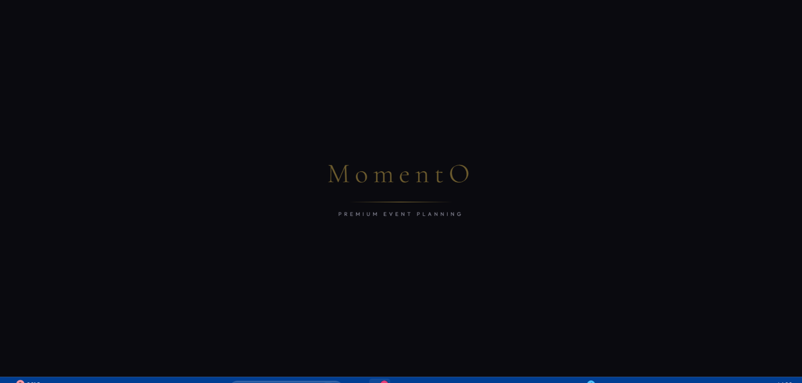

Fig 8.1 Screenshot for Welcome Animation

Description:

When the app opens, a loading screen appears shwing the "MomentO" logo with a glowing gold line animation. Once it disappears, the home page smoothly slides up into view

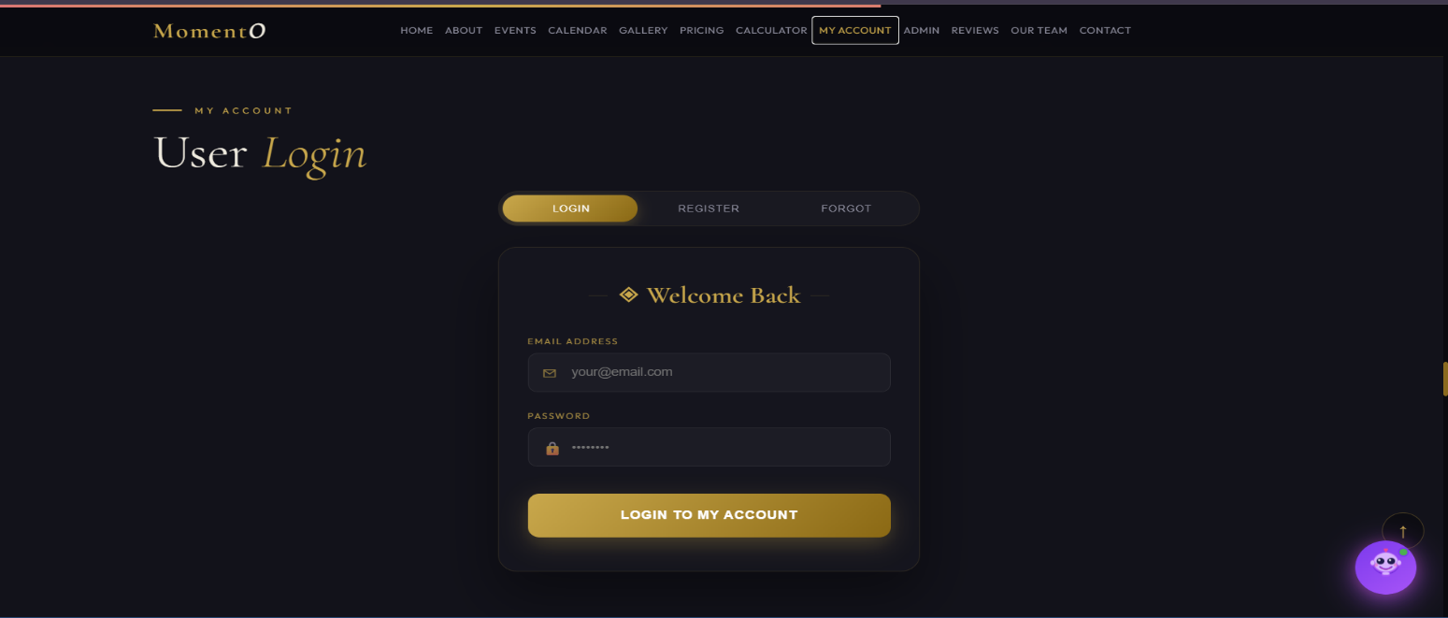

Fig 8.2 Screenshot for Register

Description:
The above Screenshot displays My Account section allows users to sign in and access a personal dashboard to track their event bookings, monitor status updates, and view invoices.

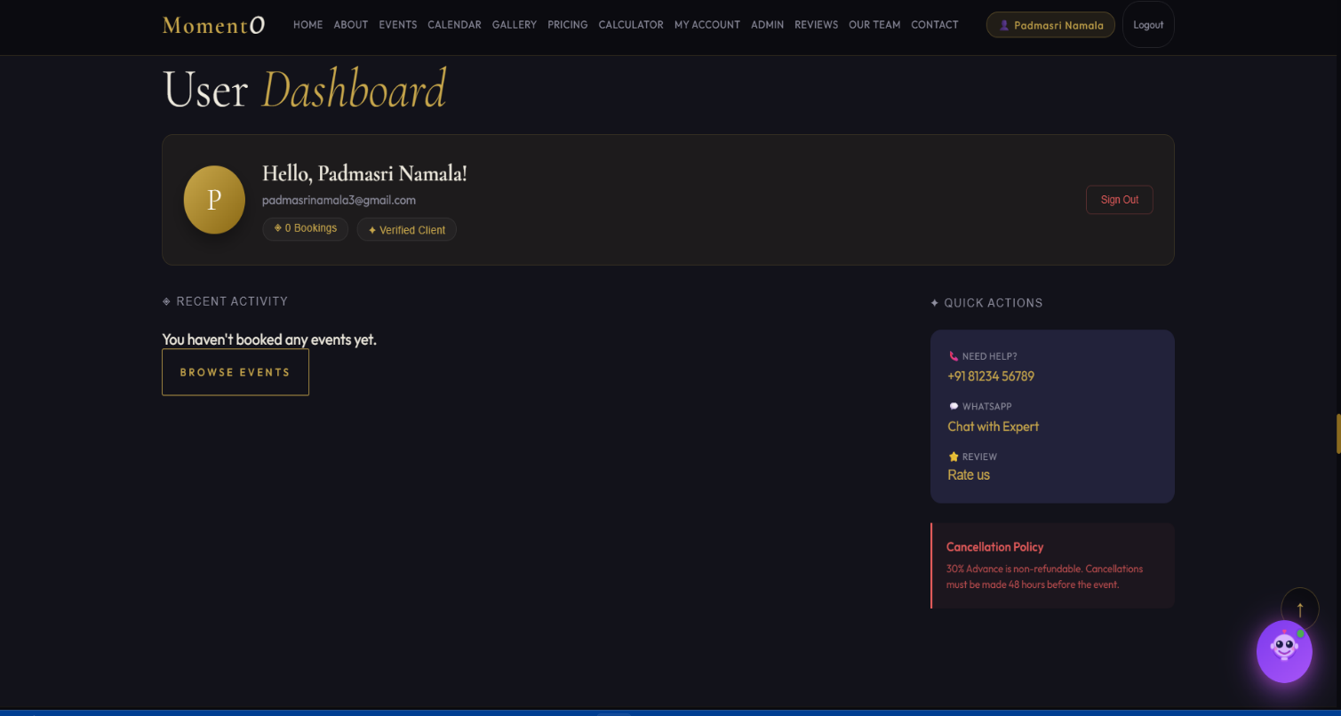

Fig 8.3 Screenshot for Successful Login

Description:
The above Screenshot display successful login After logging the section displays a personalized User Dashboard with a welcome avatar, registration details, and a complete list of your past or upcoming Event Bookings including their status and invoices.
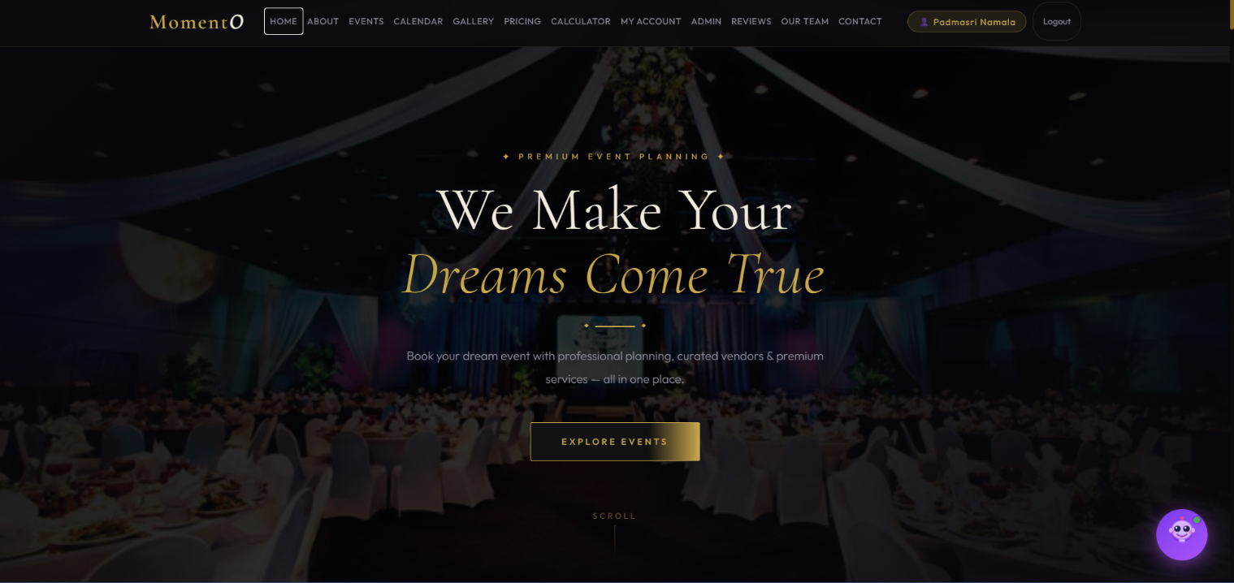

Fig 8.4 Screenshot for Home page
Description:
The above screenshot displays The Home section (Hero) is the first impression of your platform, featuring a premium background video or image with a glassmorphic overlay, bold elegant typography that slides up on entrance, and a clear "Explore Events" call-to-action to guide users into the booking process.

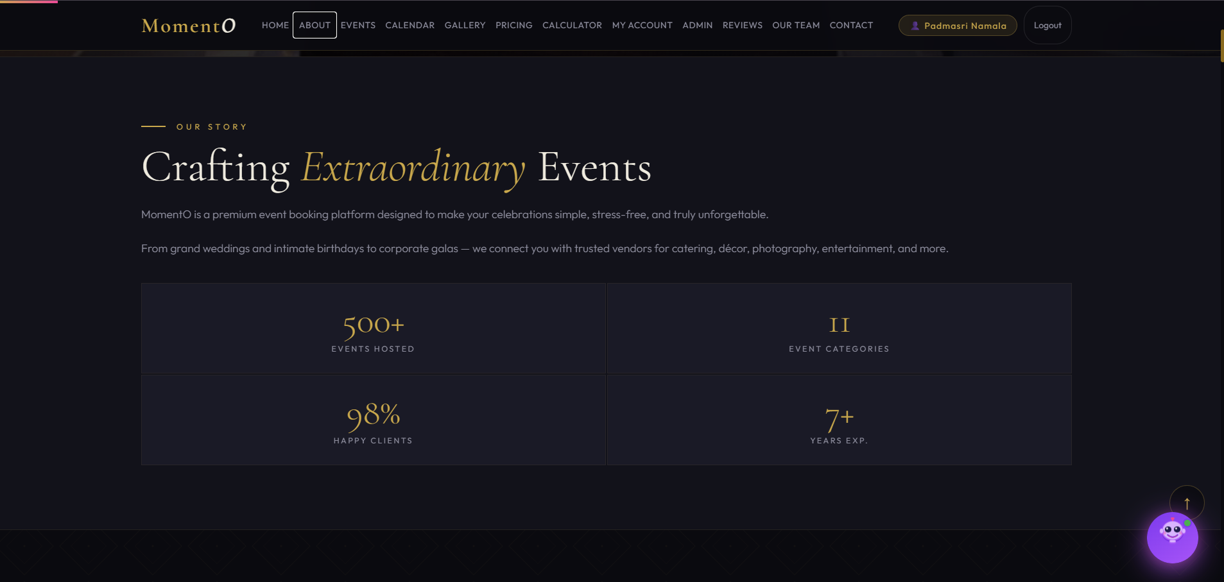

Fig 8.5 Screenshot for about section

Description:
The above screenshot displays The About section highlights MomentO's journey as a premium event planner, showcasing a storytelling narrative and a dynamic counter card that displays impressive statistics like 500+ events hosted and 98% client satisfaction.

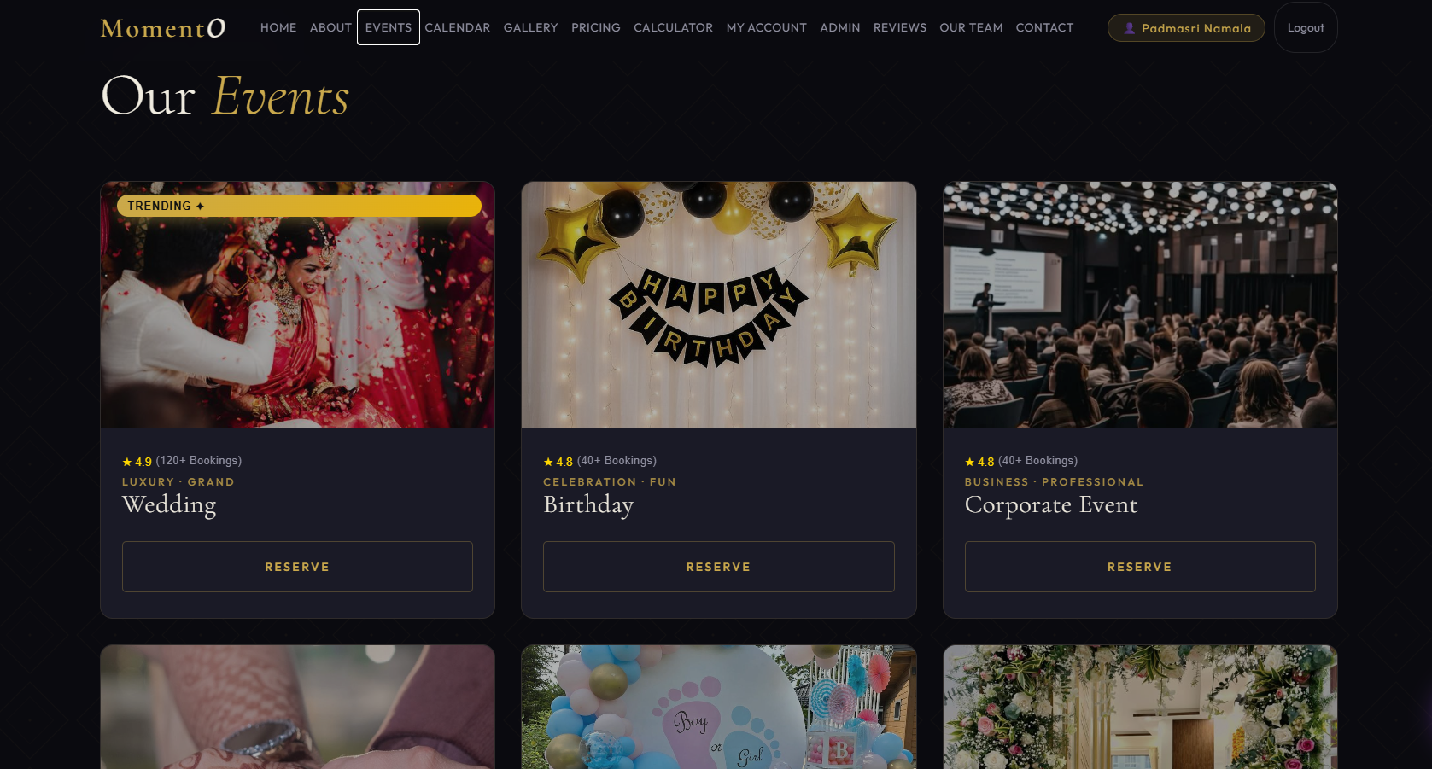
Fig 8.6 Screenshot for Events section

Description:
The above screenshot displays The Events section presents a curated gallery of luxury celebrations (from Weddings to Music Concerts) featuring interactive cards with staggered reveal animations, "Trending" badges, and transparent starting prices to help you start your planning journey.
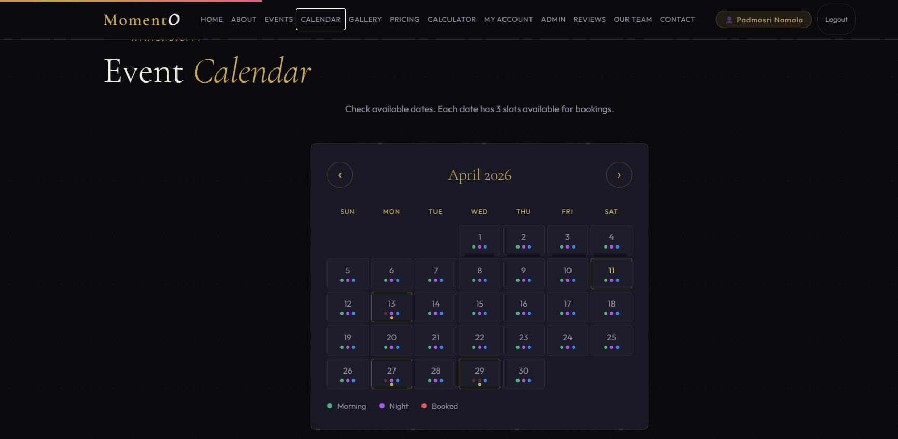
Fig 8.7 Screenshot for Calender

Description:

The above picture displays The Availability Calendar is an interactive, color-coded tool that lets you browse months and check real-time availability, allowing you to instantly identify and select open dates for your next event while clearly marking fully booked days.


Fig 8.8 Screenshot for Gallery
Description:
The above picture displays The Gallery section is an interactive, auto-playing luxury slider that showcases high-quality event memories with smooth transitions, touch-swipe support for mobile, and pagination dots for easy navigation.
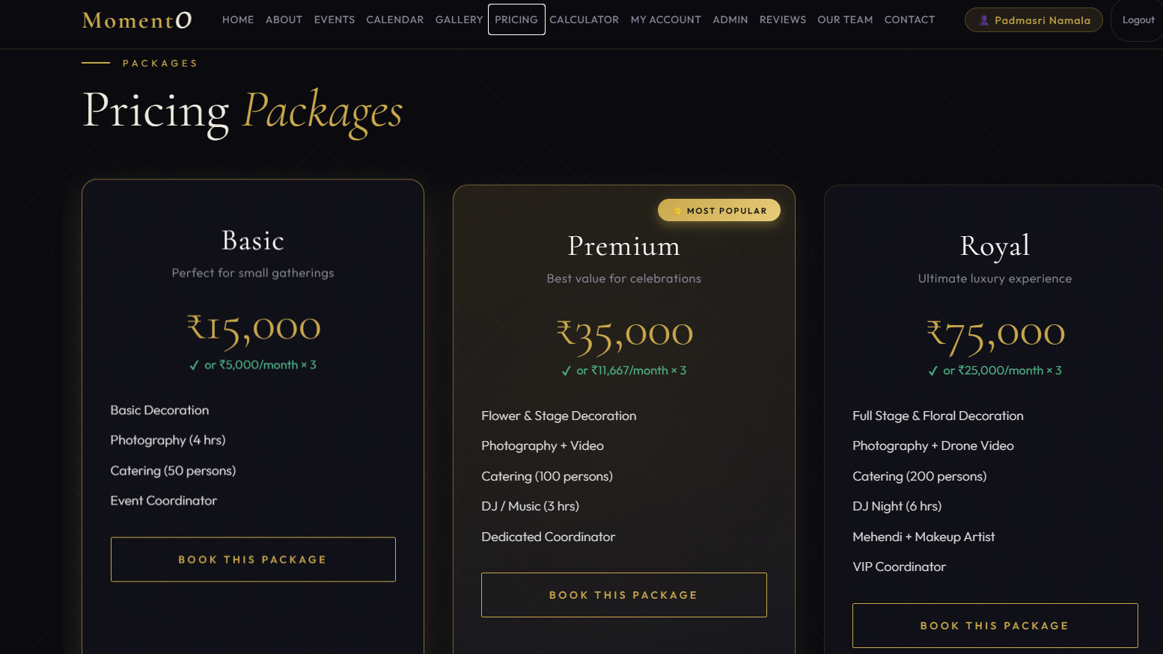
Fig 8.9 Screenshot for Pricing packages
Description:
The above picture displays The Pricing section offers three tiered packages—Basic, Premium, and Royal—each featuring detailed service lists, flexible three-segment EMI options, and a comprehensive comparison table to help you choose the perfect level of luxury for your celebration.

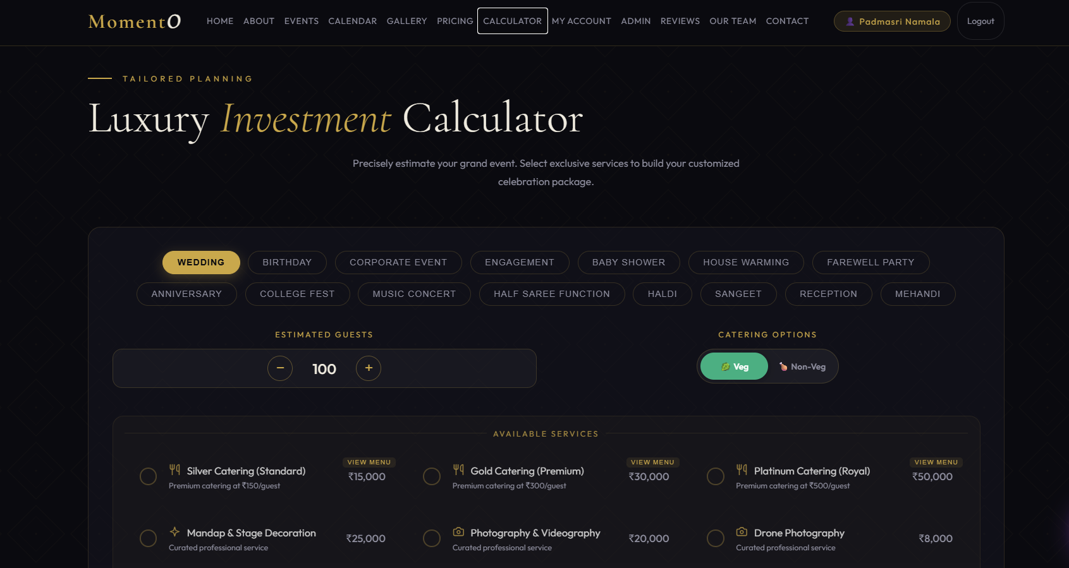

Fig 8.10 Screenshot for Investment Calculator

Description:

The above picture displays The Luxury Investment Calculator is a sophisticated, real-time customizer that lets you select event types, adjust guest counts, and toggle specialty services like catering and decor to instantly see your total investment and a 3-month flexible payment breakdown.

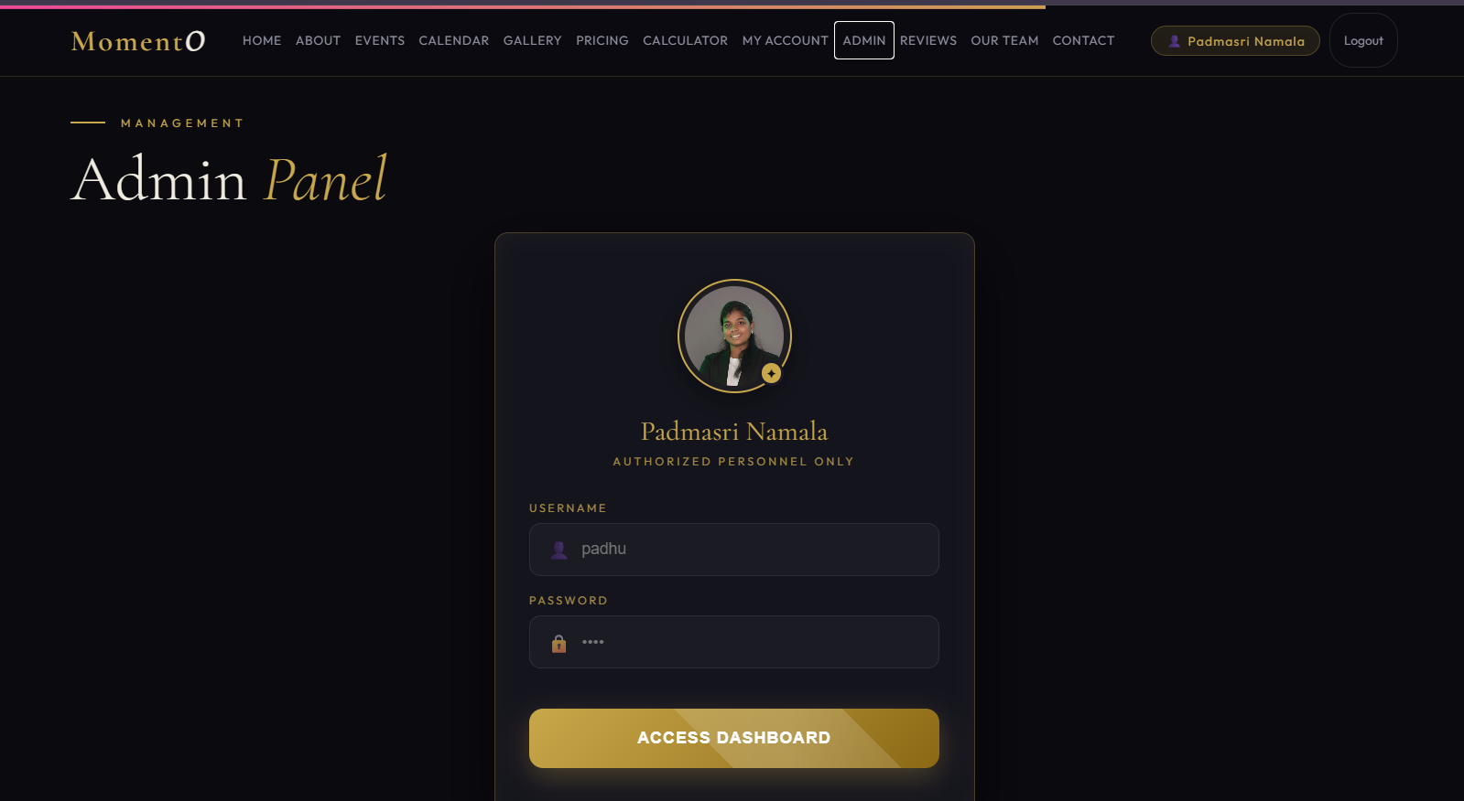

Fig 8.11 Screenshot for Admin Login

Description:

The Admin Login is a secure, personalized gateway designed for authorized personnel, featuring a premium profile avatar for Padmasri Namala and 128-bit style encryption inputs for private dashboard access.

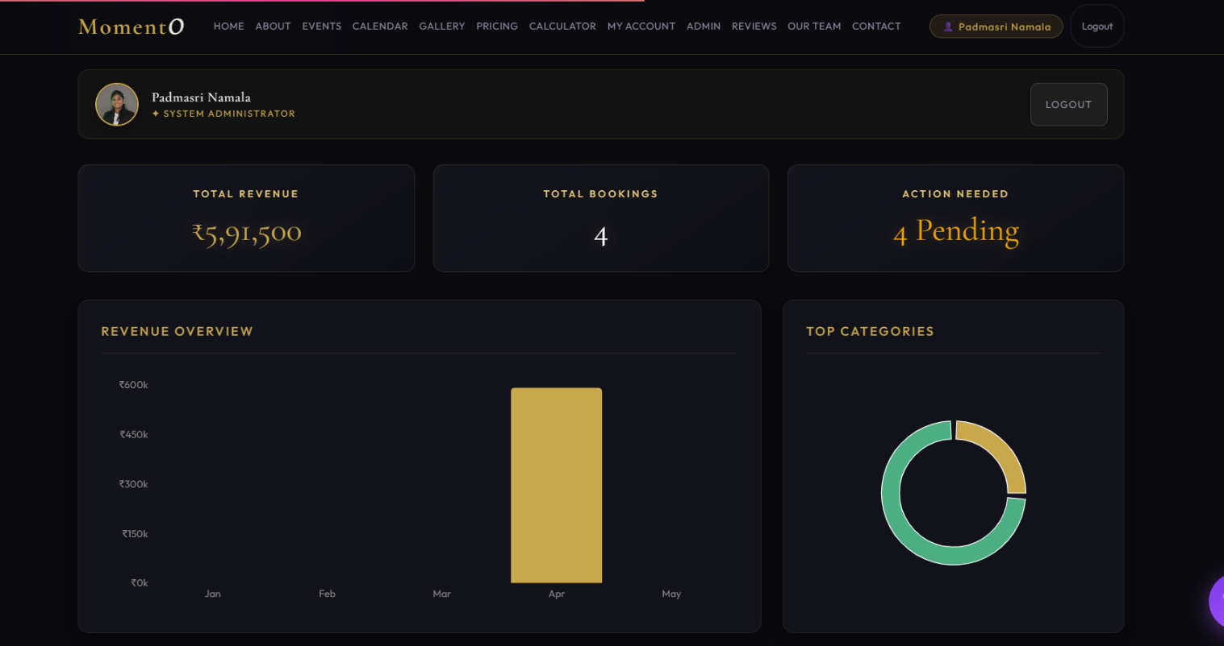

Fig 8.12 Screenshot for After Successful Admin Login

Description:

The above picture displays ,Once logged in, the Admin Dashboard transforms into a high-end control center featuring live analytics charts for revenue and bookings, a real-time notification system for new orders, and a comprehensive management hub to monitor bookings, edit events, and moderate customer reviews. 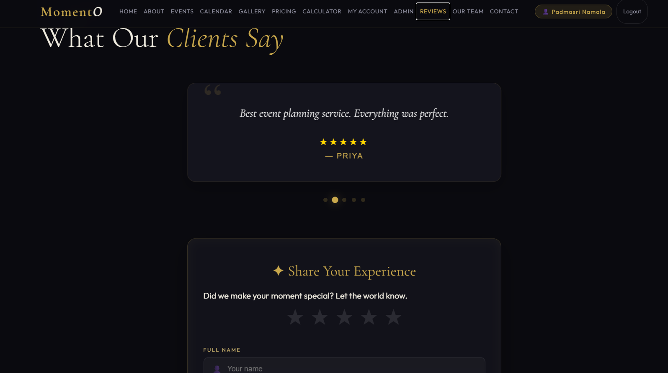

Fig 8.13 Screenshot for Reviews
Description:
The above picture displays The Reviews section serves as a trusted testimonial hub where you can browse high-rated client experiences and share your own feedback through an interactive star-rating system that updates the live platform dashboard in real-time.

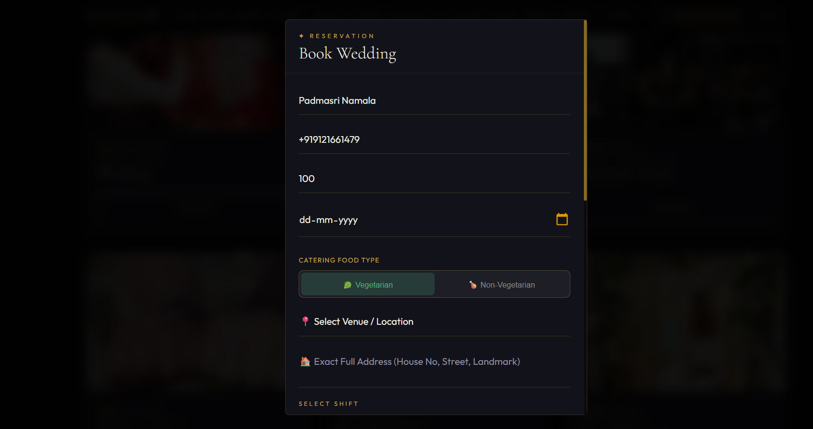
Fig 8.14 Screenshot for Booking Panel
Description:
The above picture displays The Booking Panel is a simple, luxury dashboard that opens when you click "Reserve" while logged in. It lets you customize your event by picking specific services and selecting an available date and time slot, with the total cost and payment plan updating in real-time. Once you confirm, the system saves your booking, celebrates with a confetti animation, and instantly creates a professional digital invoice for your records.

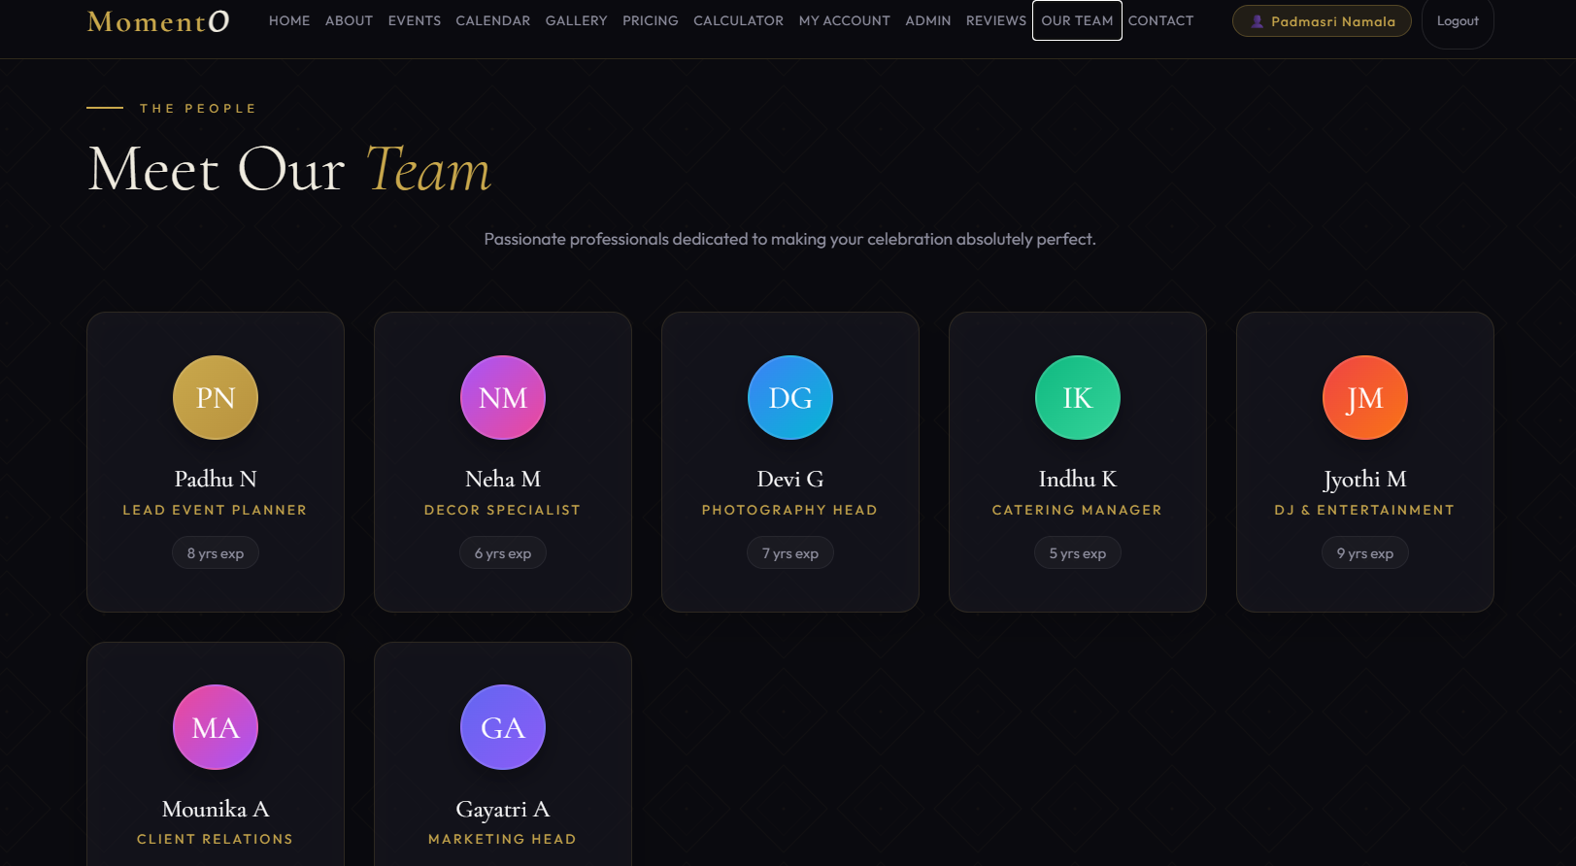

Fig 8.15 Screenshot for Meet Our Team
Description:
The above picture displays The Meet Our Team section introduces the core professionals behind MomentO, featuring elegant profile cards for experts in Photography, Catering, Entertainment, andClient Relations. Each team member is presented with a stylish, color-gradient avatar and details abouttheir years of specialized experience, reinforcing the platform's commitment to high-quality,professional event planning.

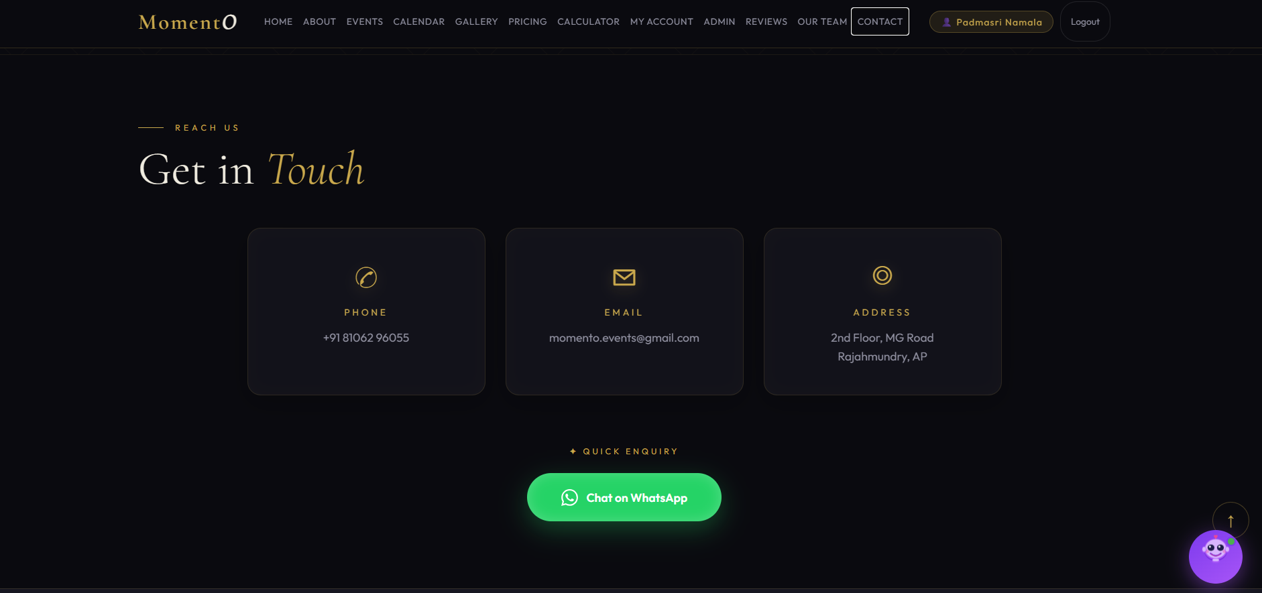

Fig 8.16 Screenshot for contact

Description:
The Project Momento platform provides multiple communication channels to ensure smooth interaction between users and the business owner. Users can reach out for queries, support, or project discussions through contact details such as phone number, email address, and WhatsApp.
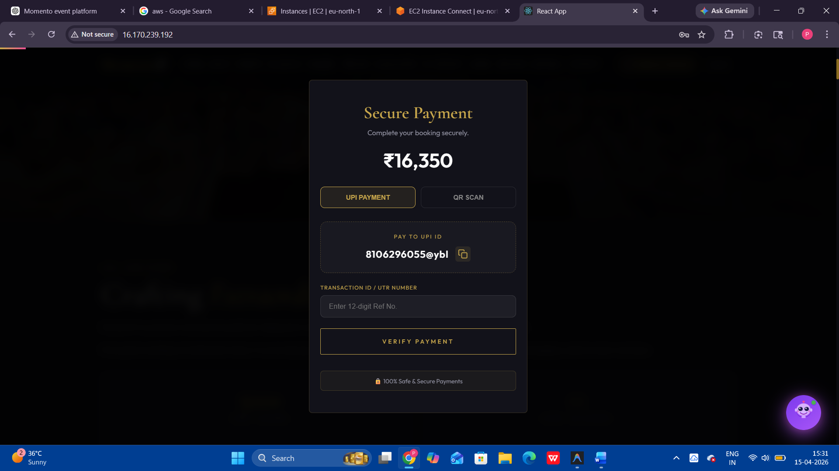

Fig8.17 Screenshot for Payment GateWay

Description:

In the MomentO Event Booking Platform, a gateway connects the application with external services like payment and communication systems. It enables secure transactions, EMI options, and sends notifications via em ail or WhatsApp. It ensures smooth and safe interaction between users and the platfo

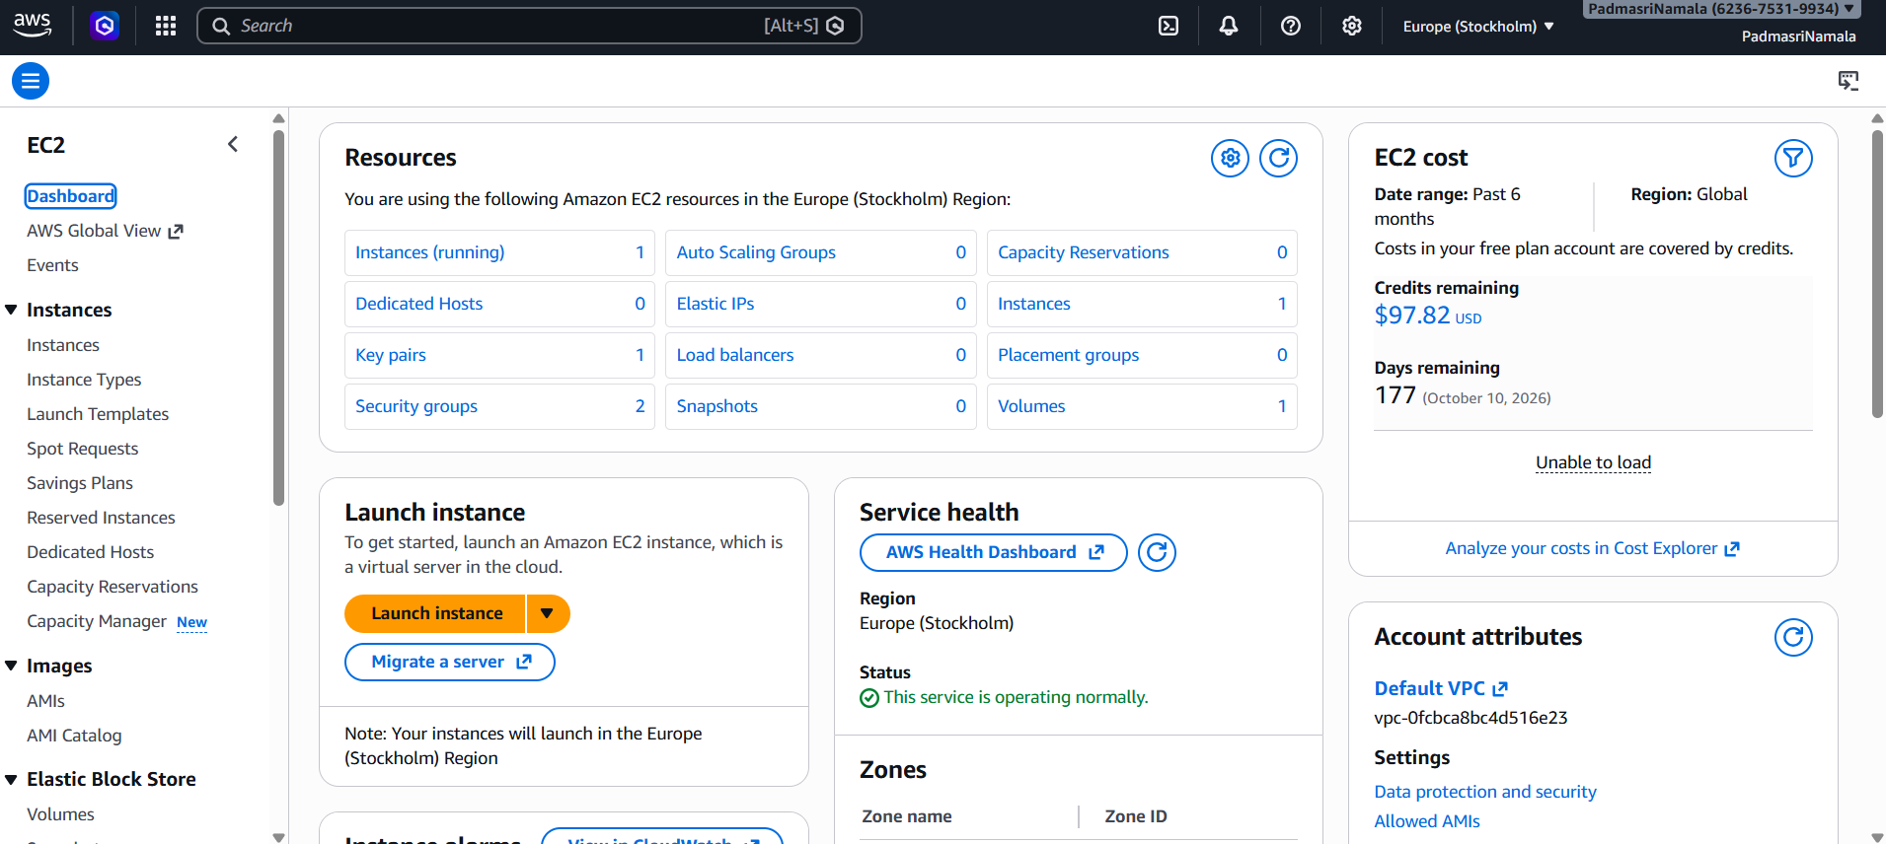

Fig8.18 Screenshot for AWS Dashboard
Description:

The AWS Dashboard is a centralized platform that helps users manage and monitor cloud-based applications and services. It provides easy access to various AWS services such as computing, storage, databases, and networking. Users can launch and manage virtual servers, deploy applications, and configure system settings through a simple interface. The dashboard allows real-time monitoring of application performance and resource usage. It also provides security features like user access control and data protection. Cost management tools help users track and optimize their expenses. Additionally, it supports scalability, allowing applications to handle increasing user traffic. Overall, the AWS Dashboard simplifies cloud management and ensures efficient deployment and maintenance of applications.

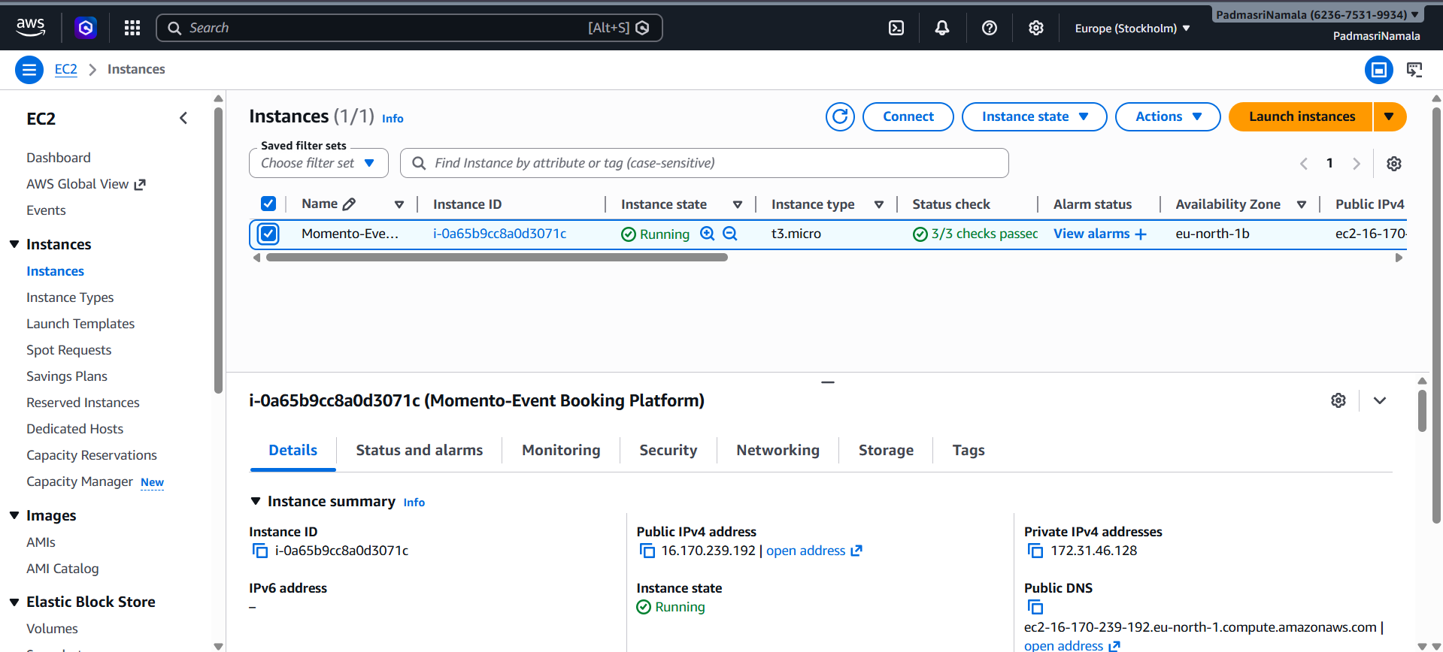

Fig8.19 Screenshot for AWS Instances
Description:
In the MomentO Event Booking Platform, AWS instances refer to virtual servers provided by Amazon Web Services that are used to host and run the application. These instances allow the backend (Node.js and Express.js) and other services to operate reliably on the cloud. AWS instances provide scalability, meaning the system can handle multiple users by increasing or decreasing resources based on demand.

They also ensure high availability, security, and performance of the application. By using AWS instances, the platform can be accessed from anywhere, and deployment becomes easier and more efficient. Overall, AWS instances help in maintaining a stable, scalable, and secure environment for the application.

CONCLUSION

CONCLUSION

The MomentO Event Booking Platform, developed using the MERN stack, provides a smart and efficient solution for modern event planning. It allows users to explore various event options, estimate budgets using a built-in calculator, and book services seamlessly through an interactive and user-friendly interface. Advanced features such as an AI chatbot, WhatsApp communication, and EMI payment options enhance accessibility and user engagement.

The MomentO Event Booking Platform, developed using the MERN stack, provides a smart and efficient solution for modern event planning. It allows users to explore various event options, estimate budgets using a built-in calculator, and book services seamlessly through an interactive and user-friendly interface. Advanced features such as an AI chatbot, WhatsApp communication, and EMI payment options enhance accessibility and user engagement.

In conclusion, MomentO successfully achieves its goal of creating a flexible, scalable, and user-centric event booking platform, making event management more convenient, organized, and accessible for both users and administrators.

BIBILIOGRAPHY

BIBILIOGRAPHY

Momento – MERN STACK APPLICATION FOR SURPRISE CELEBRATION MANAGEMENT

Books Referred
- Software Engineering: A Practitioner's Approach
Roger S. Pressman, Software Engineering: A Practitioner’s Approach, McGraw-Hill.
- Software Engineering
Ian Sommerville, Software Engineering, 10th Edition, Pearson Education.
- Design Patterns: Elements of Reusable Object-Oriented Software
Erich Gamma, Richard Helm, Ralph Johnson, John Vlissides, Addison-Wesley.
- Software Engineering: Theory and Practice
Shari Lawrence Pfleeger, Software Engineering: Theory and Practice, Prentice Hall.
- Classical and Object-Oriented Software Engineering
Stephen R. Schach, Classical and Object-Oriented Software Engineering, McGraw-Hill.
- Software Engineering: An Engineering Approach
James F. Peters & Witold Pedrycz, Wiley Publications.
- A Discipline for Software Engineering
Watts S. Humphrey, Pearson Education.

Websites Referred

  - React Official Website – https://react.dev

  - Node.js Official Website – https://nodejs.org

  - Express.js Official Website – https://expressjs.com

  - MongoDB Official Website – https://www.mongodb.com

  - MongoDB Atlas – https://www.mongodb.com/atlas

  - GitHub – https://github.com

  - Render – https://render.com

  - Nodemailer – https://nodemailer.com

  - Axios – https://axios-http.com

  - MDN Web Docs – https://developer.mozilla.org

  - W3Schools – https://www.w3schools.com

  - Stack Overflow – https://stackoverflow.com

